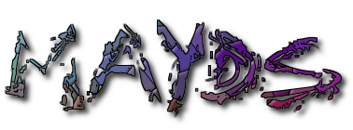

Mid Argyll Youth Development Services

50a Union Street

Lochgilphead

Argyll

PA31 8JS

Phone: 01546603231

Providing Information and Accessible Youth Friendly Services

Mid Argyll Youth Development Services

Registered Charity: SC022931

**ANNUAL REVIEW**

**2021**

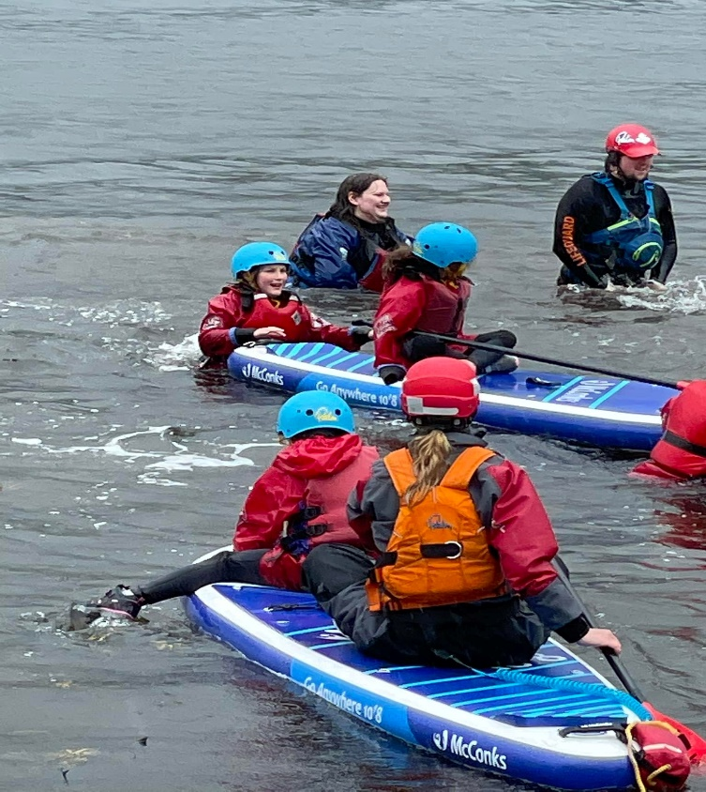

**A MESSAGE FROM THE MANAGER AND CHAIR OF THE BOARD**



**Jackie Preece. Chairwoman**

**Fiona Kalache, MBE. Manager**

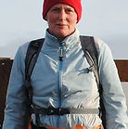

2021 has continued to be a year of uncertainty due to the Covid-19 pandemic. However, MAYDS has worked hard to adapt its services so that we can continue to support children and young people in the best possible way. We thank our partners and the community who support the work we do and most importantly to all our funders who make the work we do possible. Finally, we would like to thank and mention all the children, young people and families who continue to participate and have input into the service and importantly make the jobs we do worthwhile.

**OUR TEAM**

**Operational Team Volunteers Manager -:** Fiona Kalache, MBE **Chair-:** Jacky Preece

**Exec Assis/ Counsellor-:** Lynn Johnstone **Treasurer-:** Pasqua Facchenda

**Senior Youth Worker-:** Karen Murdoch **Trustee**-: Jean McPhee

**Young Carers Support Worker**-: Joanne Illidge **Trustee-:** Raymond Flanagan

**Youth Worker/Music Coach -:**  Neil Parkinson **Trustee-:** Stuart Scott

**Youth Worker-:** Hannah Nicolson **Trustee-:** Zandra Hunt

**Youth Worker-:** Sarah Nicolson **Volunteer-:** Mark Johnstone

**Youth Worker-:** Myrin Robertson **Volunteer-:** Michaela Bruce

**Youth Worker-:** Mena Curran **Volunteer-:** Jodie Robertson

**Outreach Youth Worker-:** Heather Kennedy **Volunteer-:** Ruby Cook

**Volunteer-:** Niamh Shaw

**Volunteer-:** Isla Ranger

**For full team profiles and pictures visit our website at www.mayds.org.uk**

**CLUBS/TRIPS**

For the majority of 2021 and working within the COVID-19 guidelines MAYDS were able to restart their clubs and activities. This was welcome news for all the children and young people we work with whom were eager to get back to socialising after the lockdown. We found clubs busy and, on some occasions, had to run 2 sessions per night to accommodate numbers within Scottish Governments COVID-19 guidelines. On any given week we saw over 135 individual children and young people accessing these activities and clubs with up to 30 at any given session. Weekly groups included J.A.M music club, junior Youth Drop in’s, Senior Youth Drop in’s, Young Carers youth club, Additional Support Needs social club and Ardrishaig Youth drop in. Unfortunately, due to the swimming pool refurbishment our long standing and free-swimming sessions were unable to run but this will restart in the spring when the pool reopens. This year we also had the team from Lochgoilhead outdoor Centre visit both Islay and Mid Argyll to provide two days of outdoor activities in each area. In Mid Argyll 24 young people attended these sessions and on Islay around 30 young people. Activities included bush craft, Archery, walks etc. During the year and over 4 sessions a member of the Community Learning and Development Centre attended P7 drop in club and worked with them to design and make wellbeing bags up for those in sheltered accommodation and the local care home. The bags included cosy socks, mugs, hot chocolate, hand made decorations etc., and the young people distributed them. Those receiving the bags were delighted particularly AFTER LONG PERIODS OF Isolation during COVID. We also worked with the GRAB Trust during the summer where 12 young people carried out 2 days of litter picks at local beaches. In December this year we had a trip to the pantomime at the SECC, we gave away a hundred tickets to children, young people and families. Everyone had a great day and enjoyed getting away and back to some normality.

**COUNSELLING AND SUPPORT**

This year our referrals to the counselling service have increased significantly with our counsellor seeing children and young people between the ages of 4 and 18 years old. The children and young people referred are done so for several reasons including early childhood trauma, anxiety, self-harm, eating disorders etc. In addition to this the counsellor visited the schools, where allowed, on a regular basis to see young people whom are struggling. Where need be sessions were delivered by zoom or telephone. In 2021 around 65 children and young people accessed the counselling service. Our counsellor also continued to develop her skills and knowledge during the year by undertaking training in relationships and eating disorders. In addition to the counselling service in 2021 MAYDS continued to hold run the Cool2 talk online support service, this was a well-used service during the year with young people being able to get advice and sign posted to support services on a range of issues. Those with additional support needs were continued to be supported on a one to one basis through our ASN social club. This club ran twice per week and gave those with complex needs a space of their own while allowing the family respite. There wer around 5 young people attending these sessions where they took part in various activities fully supported by qualified youth staff. There was also support for parents during the year through MAYDS hall being used for POP parenting courses.

**OUTREACH/DRUG AND ALCOHOL EDUCATION**

Our outreach STREET MAYDS continued to run several times a week, particularly in the summer where the nights were longer. MAYDS staff would work with the police and go to areas of concern where young people may be hanging around and drinking etc. MAYDS staff would talk to the young people and encourage them to come to the centre or give advice and information where need be. This has always been a successful program and is also running on Islay now.

**YOUNG CARERS**

MAYDS continued to hold the commissioning services for young carers across MAKI in 2021. We had a total of 112 young carers on our books during this period all accessing a wide range of support and respite from MAYDS. These services included counselling, family support, respite through pony club, accessing groups and activities. Young carers also attendee the Lochgoilhead activities and some of them attended the pantomime with their families. Through Flexible Funding we were able to support young carers and their families in various ways such as gym passes, electricity top – ups, food parcels, devices for school work etc. MAYDS continues to hold this contract until 2023.

**EMPLOYBILITY AND TRAINING**

Through our Workingrite employability and training program 15 young people were supported into positive destinations. These young people accessed up to 26 weeks on our program where they undertook modules and developed employability skills. In addition, they were matched with local employers for work experience placements. The success rate for apprenticeships and jobs at the end of the program was around 90% with young people now in apprenticeships in bricklaying, plumbing, plant mechanics, joinery, youth services, plant hire services. Staff continued to train during the year in MAKATON, detached Youth Work, Mental Health etc.

**NEW DEVELOPMENT**

Thanks to funding from RENEWI this year we were able to clear and flatten the site for the new skatepark development and pay for security fencing to be erected. The next phase is for the skatepark design and build.

**CARE PACKAGES**

During the Christmas period we received several donations from local companies to support those most in need at Christmas. Thanks to these donations we were able to top up electricity cards, provide food and amazon vouchers, give out Christmas gifts and Christmas hampers. Over 30 families benefited from these donations. During the year we also continued to work with local food bank taking their surplus stock and distributing food parcels to our young parents, young cares and others in need. We also set up a mini food bank ourselves buying and collecting food donations and distributing food to families when needed.

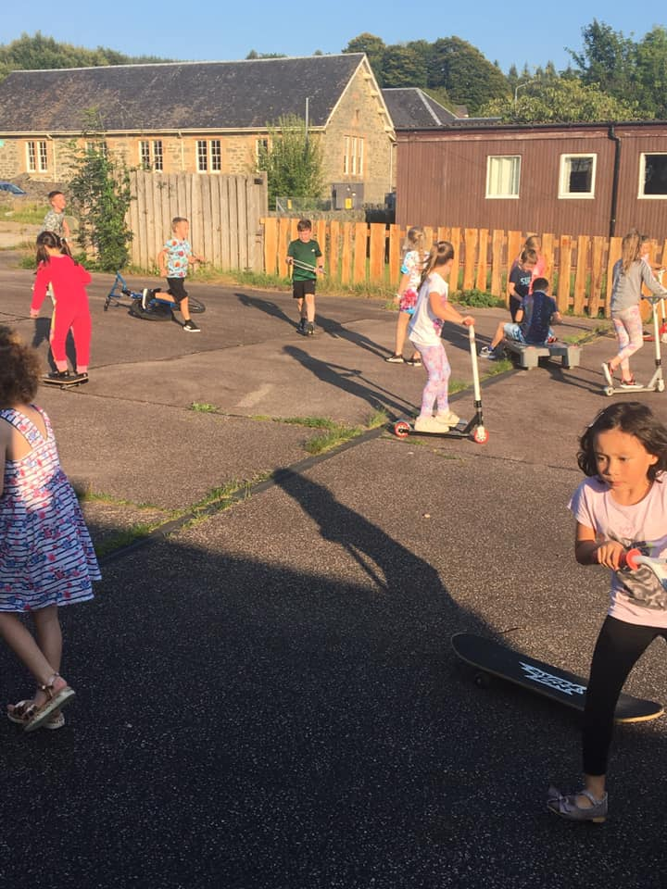 **Outdoor play at Primary Drop In.**

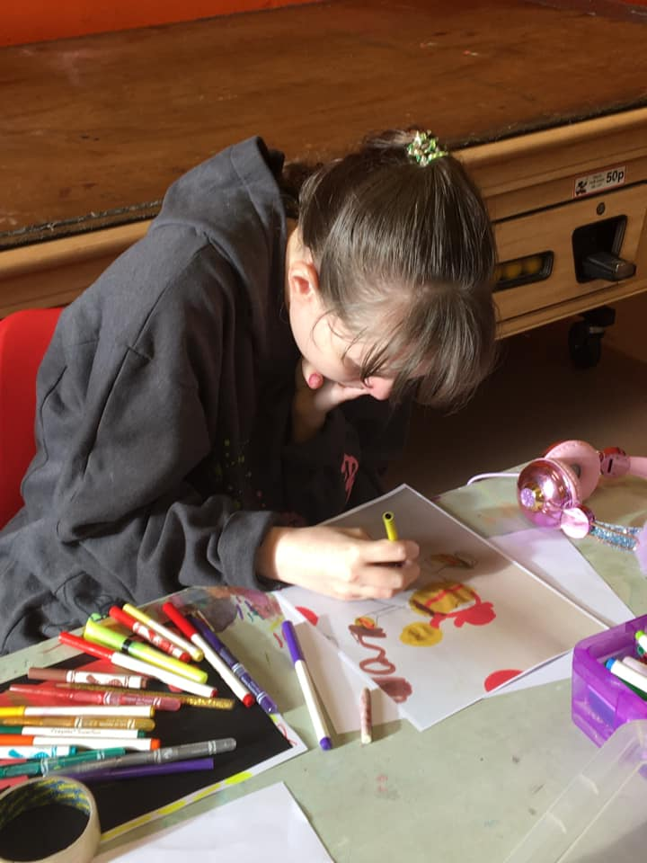 **Art at ASN social club**

**OUR FUNDERS**

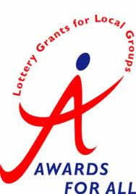 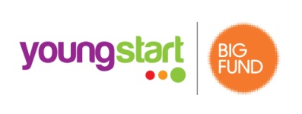 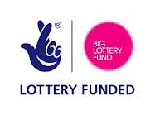 

**THE KILFINAN TRUST [](https://www.google.co.uk/imgres?imgurl=https://garfieldweston.org/wp-content/themes/garfieldweston/assets/images/search-default.png&imgrefurl=https://garfieldweston.org/what-we-do/news/&docid=a1FMpxMUiWO8gM&tbnid=hp9fkb_yySau2M:&vet=10ahUKEwjLh4WusqvnAhU3TxUIHTZQC2MQMwhJKAIwAg..i&w=600&h=400&bih=967&biw=1920&q=garfield%20weston%20foundation%20logo&ved=0ahUKEwjLh4WusqvnAhU3TxUIHTZQC2MQMwhJKAIwAg&iact=mrc&uact=8) 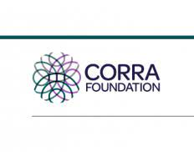 **

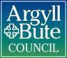   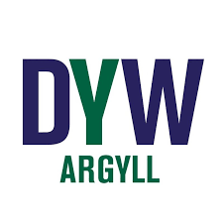 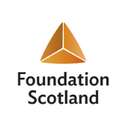

**MacTaggart Third Fund **

 