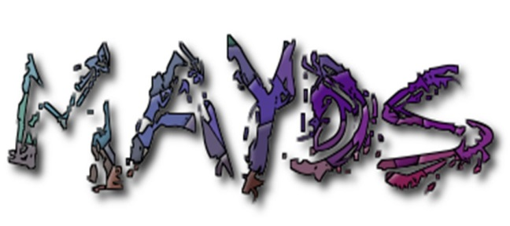

Mid Argyll Youth Development Services
Providing Information and Accessible Youth Friendly Services

Registered Charity: SC022931

UNIVERSAL REFERRAL FORM

Referrer Details-:

Name-:

Relationship to Young Person

Agency (if applicable)-:

Telephone-: E-mail-:

Young Person Details-:

Name-:

Address-:

D.O.B.-: Contact Number:

School-: Year-:

Parent / Guardian Details:

Name:

Telephone-: Email:

Parent Consent given for young person to be seen in school: Yes No
Reason for Referral (tick where applicable)-:

Young Parents Support Young Carers

Tenancy Support Drug and Alcohol Support/Education

Employability Support Flexible Learning Plan

LGBTQI Family Support

Diversionary Activities Other (please state)

Counselling

Relevant Details-: i.e. For Young Carer referral – information required about the cared for person i.e Diagnosis, how the Young Person is affected, how they support the cared for person.
All referrals - concerns, risk, issues, other agency involvement, any other relevant information.

Signed……………………………………………………..Date……………………………………………

Office Use Only

Received By……………………………………………….Date……………………………………………

Action Taken

Data Protection :

The information you provide in this form will be used solely for dealing with your child/children as a member of The Mid Argyll Youth Development Services (MAYDS).
MAYDS has a Data Privacy Policy which can be found on our webpage and in the main office. Your data will be stored and used in accordance with this Policy.

MAYDS may arrange for photographs or videos to be taken of MAYDS activities and published on our website, annual review &/or social media channels to promote MAYDS.

PARENTAL/GUARDIAN/AGENCY CONSENT (for children under 18)

If you consent to the use of your child’s image being used for the purposes above please tick here.

If you/ the individuals listed above later wish to withdraw consent, please contact MAYDS main office on 01546 603231.
By agreeing to your images being used, you agree to assign any copyright or any other right of ownership of these images to MAYDS.

Signature…………………………………………………………….Date……………………………

If you have any queries, questions or comments on the information above please contact MAYDS main office

Please return completed form either by email to; fiona@mayds.org.uk, or lynn@mayds.org.uk

Or by Post or hand to; MAYDS, 50 A Union Street, Lochgilphead, Argyll. PA31 8JS

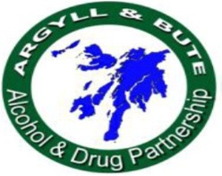
Please do not hesitate to call if you would like to discuss this referral or have any questions - 01546 603231.




