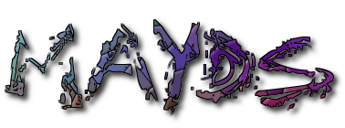
Mid Argyll Youth Development Services
50a Union Street
Lochgilphead
Argyll
PA31 8JS

Phone: 01546603231
Providing Information and Accessible Youth Friendly Services
Mid Argyll Youth Development Services
Registered Charity: SC022931

ANNUAL REPORT 2019

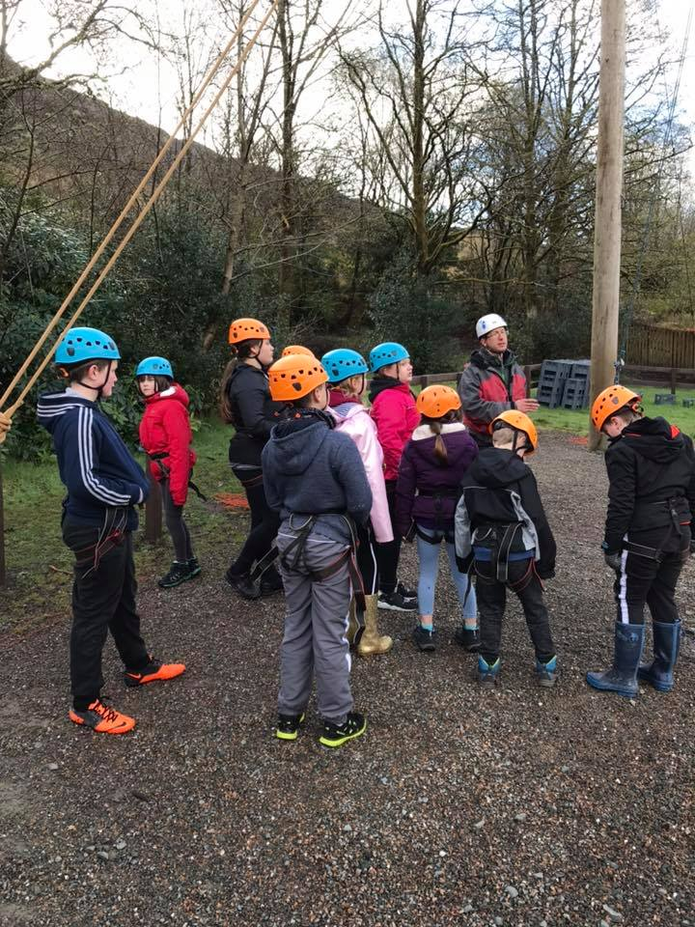

A MESSAGE FROM THE MANAGER AND CHAIR OF THE BOARD

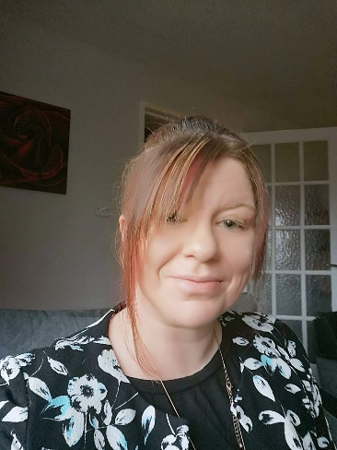
Jackie Preece. Chairwoman
Fiona Kalache, MBE. Manager
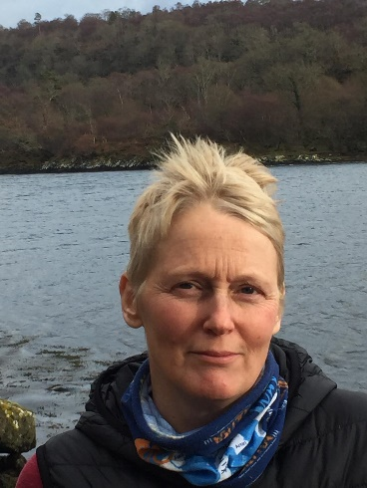

2019 has been a great year at MAYDS. We are now working with more children and young people than ever before and have continued to introduce new services and run existing programs that meet the needs and wants of the local children and young people. We continue to thank our partners and the community who support the work we do and most importantly to all our funders who make the work we do possible. Finally, we would like to mention and thank all the children, young people and families who continue to participate and have input into the service and most importantly make the jobs we do worthwhile.

OUR TEAM

Operational Team Volunteers Manager -: Fiona Kalache, MBE Chair-: Jacky Preece
Exec Assis/ Trainee Counsellor-: Lynn Johnstone Treasurer-: Pasqua Faccenda
Senior Youth Worker-: Karen Murdoch Trustee-: Raymond Flanagan
Youth Worker/Music Coach -: Neil Parkinson Trustee-: Peter Hogbin
Youth Worker-: Andrea Fisher Trustee-: Mark Middleton
Youth Worker-: Caroline Smith Volunteer-: Kevin Poppleton
Youth Worker-: Nathan Rumney Volunteer-: Aidan Kerr
Youth Worker-: Sarah Nicolson Volunteer-: Anthony Flower
Youth Worker-: Andrea Fisher Volunteer-: Ailsa Wilson
Youth Worker/Dance Tutor-: Eve Maxwell Volunteer-: Christina Simpson
Drama Coach-: James Quarton Volunteer-: Hannah Nicolson
Volunteer-: Rachel Murdoch
Volunteer-: Mark Johnstone
Volunteer-: Jackson MacInnes
Volunteer-: Holly Robertson

For full team profiles and pictures visit our website at www.mayds.org.uk

Over the last year MAYDS has continued to grow and developed both its support and tailor-made services as well as its diversionary and educational programs for children and young people 0-26 years old. We are busier than ever, seeing up to 285 individual children and young people accessing our services on a weekly basis, with this number increasing significantly when we run our specialised and training projects and education programs in the schools. Our weekly program of diversionary activities has continued to flourish and grow and along with continuing our programs such girls free swimming, JAM music club, Ardrishaig drop in, S1 Chill out, 5 Alive Club, Youth Drop-in's, horse-riding, dance club, trips and outings etc. we have introduced new recreational activities such as gardening club, ASN drop in, ASN dance therapy etc. All our diversionary programs are well attended, with a number of sessions almost at capacity, for example we have had to split our girl’s free swimming into 2 sessions now as we have over 55 young people in attendance on a Tuesday evening. All the recreational programs we run give the children and young people we work with time to socialise, learn new skills and build confidence while offering alternative outlet’s in a rural area where there are limited recreational opportunities. By offering such activities MAYDS is breaking down barriers and helping strengthen services that allow young people to grow in areas such as mental and physical health and wellbeing, increase resilience etc. In addition to our diversionary program our tailor-made support services and programs have expanded over the course of the last year. We are continuing offering targeted programs such as young parents support group, tenancy support, training initiatives and Workingrite placements, alternate curriculum options such as flexible learning plans and Youth Achievement Awards, young carers program, drug and alcohol education etc. We have increased sessions around wellbeing via cool2talk online support, one to one support, family support and counselling and play therapy services to address some of the main issues highlighted by young people and partner agencies locally, including the need for more support for those affected by issues including mental health, offending or at risk of, young people with anger issues etc. Our support services continue cover a range of priorities including-:
Help at a critical moment -: Over the last year referrals to MAYDS to support individual young people, specifically from education and social work, have doubled. Most of these referrals are for young people whom are at crisis and need support due to issues such as individual drug use, mental wellbeing, family breakdown and those offending or at risk of offending. MAYDS qualified staff offer these young people individual support on a weekly basis where they look at specific areas of concern and try to help the young people look at their behaviour, issues and use various tools to work through them such as anger workbooks, knife crime programs etc. In addition MAYDS will support young people to access other relevant services that can help and also try to engage them in positive recreational activities with the overall aim of building their self-esteem, confidence and coping skills and mechanisms. Within the area of individual support, MAYDS also offers counselling sessions, free of charge, both within our service and 3 of the area’s secondary schools. Our trained counsellors work with these children and young people needing more intense support from professionals with expertise. With MAYDS counsellors being the only one’s qualified in child and adolescent to work in the area this service has proved vital in supporting those who are most vulnerable and at risk. In addition, our counsellors have been using play therapy to support children who have been impacted by trauma or are struggling with anger or social issues due to additional support needs. In 2019 we established our Assisted Supported Needs (ASN) drop in, this club recognised the need for those with significant special needs to have a social night in a safe and supported environment, it also allowed the parents and siblings of these children to have some respite. Due to the 1 to 1 ratio of this club we can only accommodate 6 children at a time and there is currently a waiting list for this service. Over the last year MAYDS have continued to work on Argyll and Bute’s online support service. Cool2talk is a service where young people have a safe space to talk, ask questions and receive support at difficult times. Through the site young people can ask questions around general health, mental health etc. with a guaranteed answer from a professional within 24 hours. MAYDS manager and executive assistant are part of the team that answer questions. The answers will include identifying both local and national services where the young person may want to seek further guidance/help/support. As part of the service the young people can also get free online sessions with a qualified counsellor. This is a great service and MAYDS are delighted to be part of it, with the rurality of the area we live in this is a specifically effective way to help and support those at a difficult time.
Positive Choices-: During the last 12 months MAYDS has continued to work on programs and projects that enable young people to work on their behaviour and begin to make positive choices. As stated previously our individual support program works with young people whom for example have maybe been carrying knives, using drugs recreationally or not making good choices regarding their sexual health etc. We work with these young people over a period of time to address the concerns raised and look at consequences and try to implement and support changes to their behaviours. We also continue to work across the 3 secondary schools to deliver our drug and alcohol education program from S1 through to S6, promoting safe and sensible choices throughout life. Our "Street MAYDS" program continues to develop and we are now looking at recreating something similar on the island of Islay. This program sees 2 of our skilled and qualified youth workers carry out detached youth work on the streets on Friday and Saturday evenings, which are high risk times in terms of underage substance use and anti-social behaviour. The “Street MAYDS” staff work alongside the police and travel around the villages talking to and engaging with young people in the hope of building up positive relationships. They also go to areas of concern to make sure young people are safe and talk to them about subjects such as misuse of substances, making positive choices etc. They provide young people with information on any activities etc. that are on in the area with the hope of offering them an alternative to hanging about the streets and getting involved in problem behaviour. The project has been a great success so far and police have fed back that since it started they have seen a positive difference in terms of underage drinking and anti-social behaviour on the streets, specifically on Friday and Saturday evenings. Also, since “Street MAYDS” has progressed numbers at our Friday evening club have tripled and due to demand we are now also opened for a senior drop in on Saturday evening till 11pm.
Housing Support -: We have continued to run our housing support services through both our tenancy support Program and individual support needed when housing services refer young people in need of help to MAYDS. Again this year our tenancy support program helped those young people entering new tenancies for the first time or those struggling in their existing tenancies to gain the skills and get the support needed to enable them to successfully live independently. The 12 week program covered areas such as budgeting, debt management, substance misuse and antisocial behaviour, being a good neighbour, cooking on a budget etc. In addition to this the young people undertook their First Aid and Food Hygiene certificates, giving them transferrable skills that may help lead them into employment. MAYDS relationship with the local housing authority has grown and over the last year they have referred several young people to us who needed additional support in their homes. The services MAYDS offers these young people includes help and advice on budgeting, introducing and referring to additional support networks including advocacy, citizens advice, home start etc., and sourcing of affordable furniture, electrical and phone packages. Over the last year MAYDS has also been able to support young people most in need through food parcel donations.

Employment/Training-: Part of the work continued by MAYDS over the last year has been to support young people not in training, education and employment (NEET), into positive destinations. We do this via several programs including our partnership with workingrite, our volunteer and work experience program, our training program and our project giving young people to alternate curriculum. MAYDS continued to work alongside workingrite to refer the harder to engage young people into 12 week supported employment with the hope that this will either lead to a fulltime job or apprenticeship. This year we have placed young people in local hotels doing catering, fish farms, engineering placements, hairdressing and construction. During their 12 weeks the young people are fully supported and also access training around ready for work certificates and any other training that would enhance their positions in that job (e.g. for those in construction placements we will provide them with their CSCS card training). Our volunteer program has continued to grow and develop and over the last year we have seen ourselves working with more volunteers than before. All our volunteers have access to free training and this year some of the courses and certificates they have achieved include internet safety, safeguarding, fire marshal, first aid etc. Our volunteers come along to clubs and projects where they are fully supported by trained staff and where they work across a range of disciplines including youth drop in's, our drama and music clubs as well as supporting trips and outings and projects such as young parents support and young carers support. For some of our younger volunteers, whom are not academic or do not engage well in school, the certificates and training they get via MAYDS is vital and for many we have seen a real development in confidence and self-esteem. Part of MAYDS remit is also to provide various training course, free of charge for young people. This is in a bid to enhance their CV’s, skills and employment opportunities. During the last year we have put young people through many course including sound production, music writing and recording, HSE tests etc. MAYDS continues to offer alternate curriculum programs and work experience placements for those who are not engaging well in school or have more practical rather than academic abilities. This year we continued running the Youth Achievement and Dynamic Youth Awards Program. This program allows young people to achieve in an environment using the skills best suited to them. It is adaptable and individual focused allowing those less likely to achieve in school a platform to learn and gain qualifications they otherwise would not have had.

Support Networks and Family-: Over the course of the last year MAYDS has continued to support families to have positive relations and be socially connected through our young parents support program, MAYDS family’s program and young carer’s project. The aim of these programs is to support families most in need through reducing isolations, respite time away from caring roles, social inclusion and increasing resilience and mental wellbeing. Over the course of the year both our young parents support and MAYDS families initiative regularly bring together parents and children to socialise, but also learn new skills and enhance knowledge around being parents through visits from Child Smile, Book Bug's, Health Visitors etc. Our young cares support project has continued to offer respite to young people in a caring role, for them this has helped reduce isolation and provide time away for where they can socialise and have fun. This year our young carers have attended residential, various trips, pony club etc. Getting time away for young carers can reduce the strain on the whole family and increase the young person’s resilience and independence. We now also hold the commissioning for Young Carers Statutory Services across Mid Argyll, Kintyre and Islay.
In addition to the above MAYDS continues its community events such as the annual Sport's NOT on the Green event, our JAM groups music events at the school and community halls and workshops with a professional band and our diversionary dance group performing for the community.
The last year has seen MAYDS Manager continue to build the services partnerships up through sitting and having input on Child's Plans and attending agency meetings such as Opportunities for All, Children First Meeting, Substance Misuse Forum etc. Also, this year the Manager now sits as a representative on the Argyll and Bute Drugs All Our Children’s Partnership. We are also delighted to announce that on 28th December 2019 our Manager, Fiona Kalache, was awarded an MBE in the Queens 2020 New Years Honours List. This is for her role as Manager of MAYDS and for Services to Young people in Mid Argyll.

SPECIFIC OUTCOMES for the year 2019

Over 350 children and young people have had access to diversionary and recreational activities that helps increase confidence, self-esteem, physical and mental wellbeing.

15 young people participated in a 3-day outdoor residential to Lochgoilhead.

40 families were supported to attend a Christmas pantomime, free of charge, in the city.

Over 150 children and young people benefited from free trips and outings away.

20 young carers received respite from weekly pony club sessions.

Around 50 children and young people participated in Young Carers Statements.

8 young people with additional needs benefited from Dance Therapy sessions.

6 children with additional support needs benefited from our ASN supported drop in.

Over 350 community members benefited from our events such as concerts, Sports not on the Green etc.

12 young people received housing support.

34 young people were supported into further education, employment and volunteering and or received alternate curricular certification.

15 families including young parents were supported through MAYDS families and young parents’ group.

5 children received play therapy.

Over 60 children and young people benefited from counselling and one to one support.

Over 800 young people benefited from drug and alcohol education

We are also delighted to announce that at the end of 2019 MAYDS Manager, Fiona Kalache, was awarded an MBE (Member of the British Empire) in the Queens 2020 New Years Honours List. This was as her role as Manager at MAYDS for services to Young People in Mid Argyll.

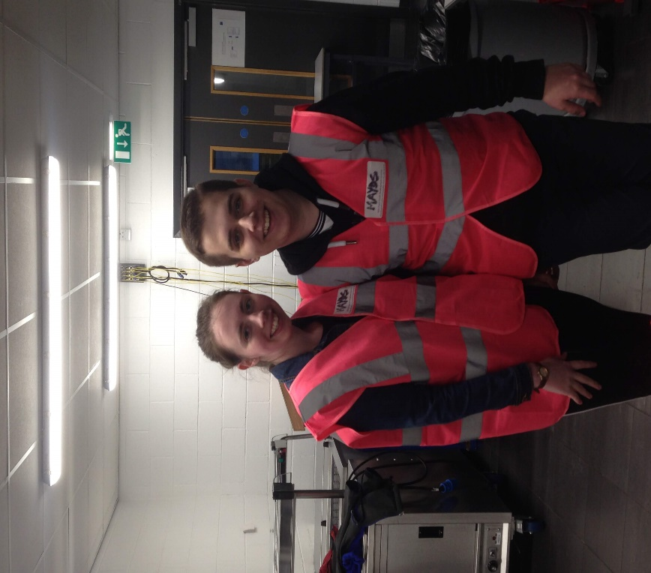

2 of MAYDS Youth Volunteers

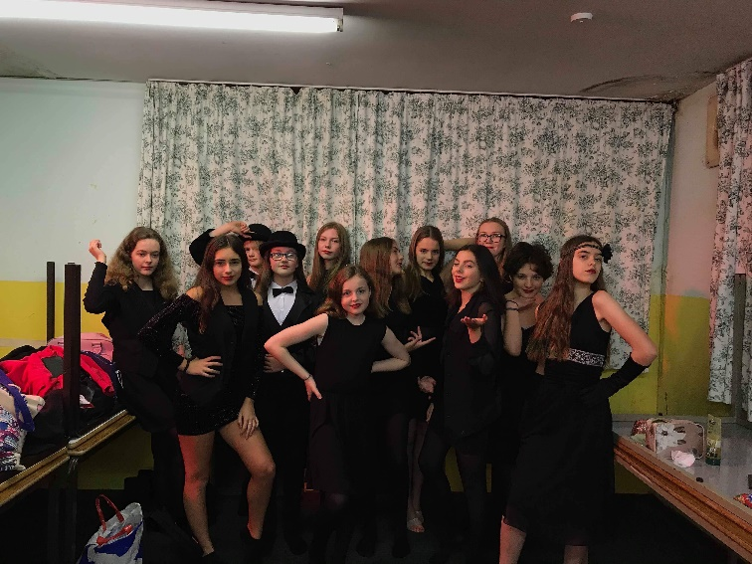
MAYDS Dance Troupe

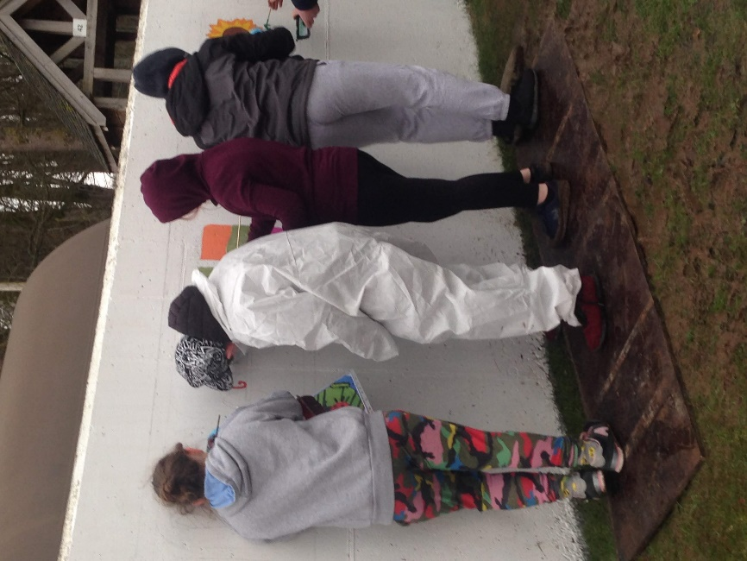

MAYDS gardening club painting a community mural.

OUR FUNDERS IN 2019

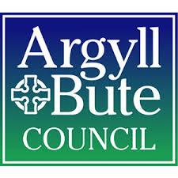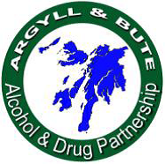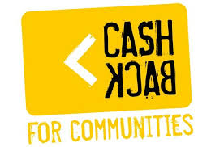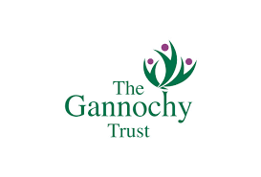

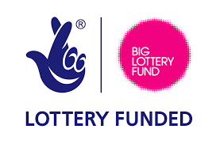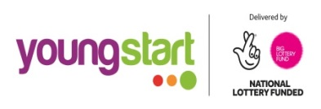

Mid Argyll Substance Misuse Forum THE KILFINAN TRUST
