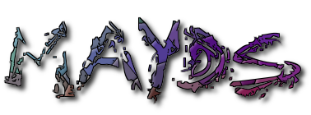
Mid Argyll Youth Development Services
Registered Charity: SC022931
MAYDS Ltd Company number: 396832
50a Union Street
Lochgilphead
Argyll
PA31 8JS

ANNUAL REPORT 2023

MAYDS would like to thank all our funders, partners, staff, volunteers and the wider community for their ongoing and continued support in helping us make a difference in children and young people’s lives. .

Below is an overview of our year.

MAYDS youth clubs and activities are as popular as ever and continue to serve the community of Mid Argyll. MAYDS has groups on 6 evenings a week and during the day on a Saturday. These groups see over 150 individual young people attending on a weekly basis. Alongside running our generic youth clubs and activities this year saw an increase in the need for our tailored support services, such as our Additional Support Needs groups, pre-employability and employability support, young carers and counselling services.
Our hall is also used by community groups during the week such as Heads Up (mental health), Dementia Choir, Baby massage and MAKI pups (outdoor nursery, when the weather is bad).
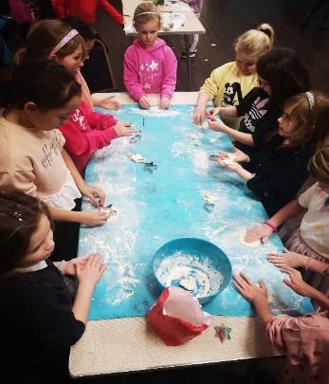 Baking at junior youth club

ASN
Our Additional Support Needs (ASN) groups have become a vital service, not only for the young people attending them but also to allow parents/carers and siblings some respite. For many of the young people attending ASN this is their only social outlet out with school. For many families this is the only opportunity they have for a few hours respite on a weekly basis, due to lack of statutory support services. Those attending the ASN sessions have such a high level of support needs that they cannot attend any generic social clubs and staff need to be on either one to one or one to two ratio. This year we have managed to recruit some new staff which has allowed us to increase the intake at the two sessions. The groups are run on a Saturday, however staffing for this group is still a challenge and continues to limit the number of sessions we can run and in return the number of young people we can support. This year we have successfully supported 18 children. MAYDS still has a waiting list of families looking to access this service. Our aim for 2024 is to address our staffing needs, to allow us to support more, if not all of these young people. As well as our regular activities for those with ASN, this year we trialled an ASN roller disco and we also continued the ASN family swimming sessions which are proving popular.
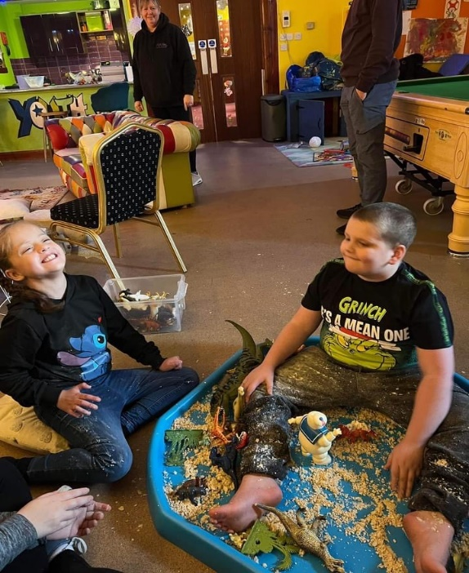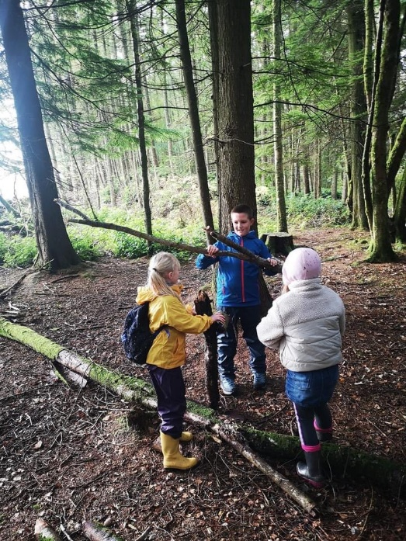
ASN Messy Play. ASN Den Building.

Young Carers
In 2023 we had over 100 young carers registered in our service across, Mid Argyll, Kintyre, and Islay. Along with undertaking their young carers statements and support plans, we also provided support through, trips, vouchers, driving lessons, college and job applications, work placements, counselling, providing tablets, clothing etc. This year we saw an increase in referrals from young people supporting parents with either addictions and/or poor mental health and from families where there was a sibling with additional support needs. To promote young carers services and try to highlight who young carers are and what young carers do, we carried out training in schools and with agencies such as social work.
2024 is the first year we attended the Young Carers Festival in Fyfe, we took 12 young carers between the ages of 12 and 17 to the two-day event. Everyone had an amazing time and got to meet other young people living in similar situations, while experiencing new opportunities and activities. This trip also enabled these young people to have a few days respite from their caring role. As well as the festival we were scheduled to take 20 young carers ages 8-10 from Mid Argyll and Islay to Lochgoilhead outdoor activity centre for 3 days day’s and 2 nights. Unfortunately, a few days before, a landslide occurred and prevented travel. Travel costs and restrictions is often a challenge we face due to the area we live in. The children were obviously disappointed but to compensate we ran activities locally and the trip is rescheduled for April.
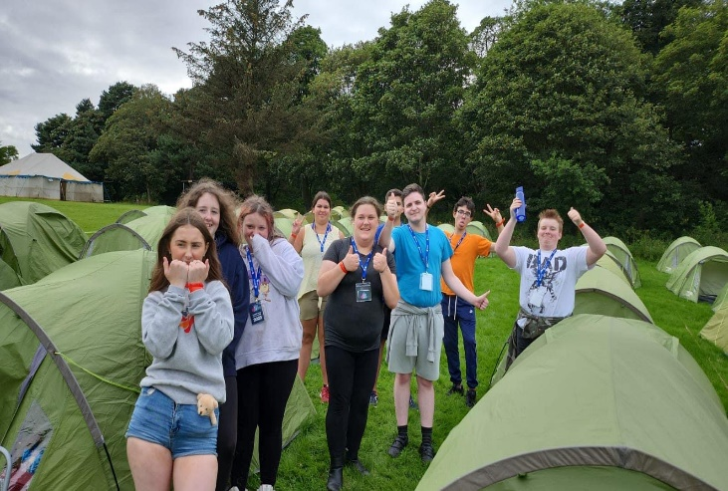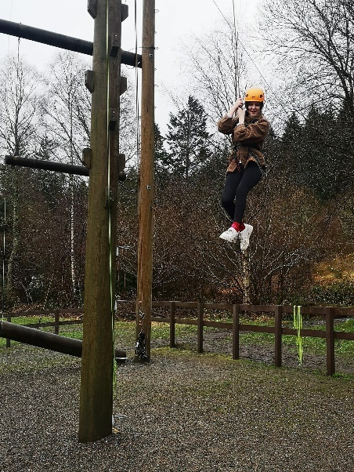
Young Carers Festival 2023. Young Carers Respite Activities.

Christmas
Christmas proved to be a very busy time for MAYDS in supporting disadvantaged families, this demographic includes; young carers along with single parent families, young people in their own tenancies and families struggling due to the cost-of-living crisis. To help support these families MAYDS were able access funding for Christmas hampers, vouchers, children’s presents, electricity etc., this allowed us to support approximately 40 families and individuals. This showed us the increasing need there is for food banks etc., and we are now working in partnership with other local agencies such as the MS Centre and Moving on Mid Argyll, to come up with a more effective approach to providing food parcels and a food bank locally.

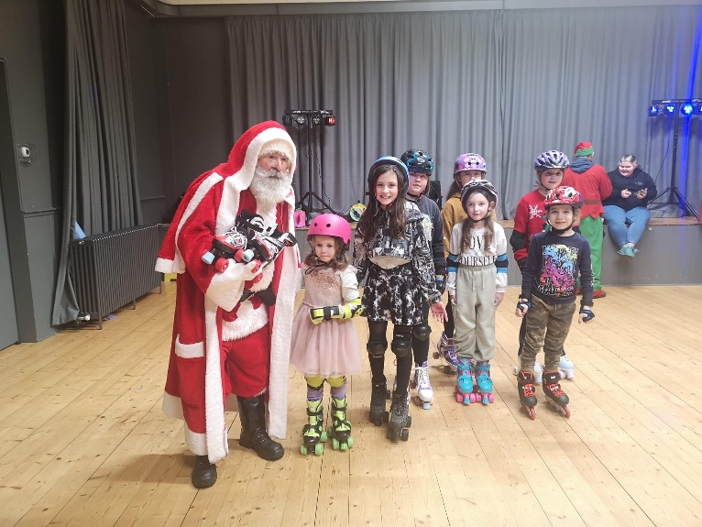
Santa at the Christmas Roller Disco.

Employability
Through our Pre-Employability program (Spark your Purpose) MAYDS has supported approximately 50 young people, 16-25 years old. This is our newest employment support initiative, that adds to our Working Right employability program. Spark your Purpose allowed 4 young people to get lifeguard training, which secured them employment at our local pool. A young girl got support and help that enabled her to secure a job at a nursery and others have been able to access theory tests, driving lessons and apply for a CSCS card. One young person attended a short hairdressing course in Glasgow.
With this program the challenge was keeping the young people engaged, this group was a combination of school non-attenders, individuals that struggled to get or sustain employment and those with mental health issues.
We have supported several young people into positive destinations though our Working Rite employability program. Young people have been working in areas such as construction, leisure, gardening, plumbing and hospitality. For the first time ever, this year we have managed to get a young boy a placement with Education in the IT department. The young man is a looked after young person and this was a job he really wanted to do, so we were delighted to get Argyll and Bute council on board. We also placed 2 young girls within the construction industry, one with a joiner and one with a plumber. We are finding that a lot of the construction firms we work with are keen to encourage women into the Industry and there are more girls taking up these opportunities.
For the first time this year we ran a pilot program with Working Rite and education to deliver an earlier intervention approach to young people who were disengaging in school but could not leave yet. With the view these young people would probably get referred into Working Rite on leaving education, we decided to engage them by offering more employability skills in preparation for employment. Through the Rite to Work program 8 young people attend MAYDS for a full school day on a Monday, here they cover certificate of work modules and work on employability skills such as rights and responsibilities, Health and Safety, etc. Despite not engaging in school the majority have had 100% attendance on this program so far, which has been a great achievement. They have also gained 3 certificates in work related skill, this is a really positive outcome, as many may have otherwise of left school with no qualifications. A similar challenge with this program is, designing a program that will keep the young people engaged, having them for a full day can be long, however we have found delivering a mix of practical skills along with the written work is effective.
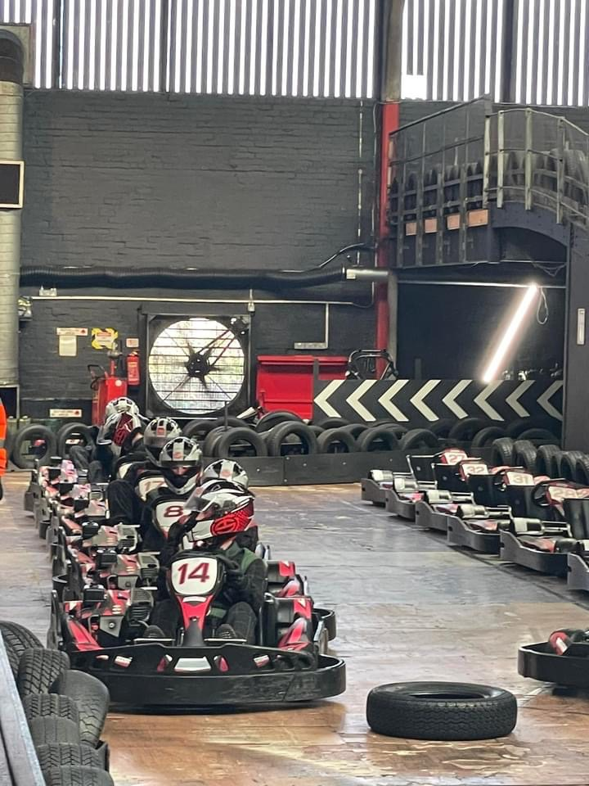
The Rite to Work students at their Christmas trip

Counselling
Referrals for counselling have been up by 50% this year, particularly for the 13-16 year age group. Young people are presenting with a variety of issues such as eating disorders, self-harm, anxiety and in general poor mental health. We have also noticed the increase in the number of parents reaching out to us for support, particularly those parents who have children with ASD. Our counsellor now regularly sees parents for sessions, to offer them some support and a safe space to talk.
Funding has also allowed us to start a new program to offer long term therapy rather than the standard 8 to 10 sessions. This will initially run on Islay for a year. MAYDS counsellor will engage with a minimum of 6 individuals during this time, on a weekly basis to support them through their long-term mental health struggles. The individuals on this program suffer from conditions such as anorexia, agoraphobia, personality disorders and depression. The challenge around this program is travelling to the island, particularly in the winter, when ferries can be delayed or even cancelled, however if this is the case we have zoom as a backup.
Our counsellor is continuously looking to train in different areas but finding suitable training has been a challenge due to travel, work schedules etc. She was due to start family therapy training January 2024 however, this was cancelled last minute due to lack of numbers. This was frustrating but we hope it will be rescheduled in the near future.

Staff Training
This year staff continued with their CPD via updating training such as Child Protection, Youth Work, and online safety. In addition, added some new training to their portfolios which included special education needs and disabilities, LGBTQ training and safeguarding children and young people with special education needs and disabilities.
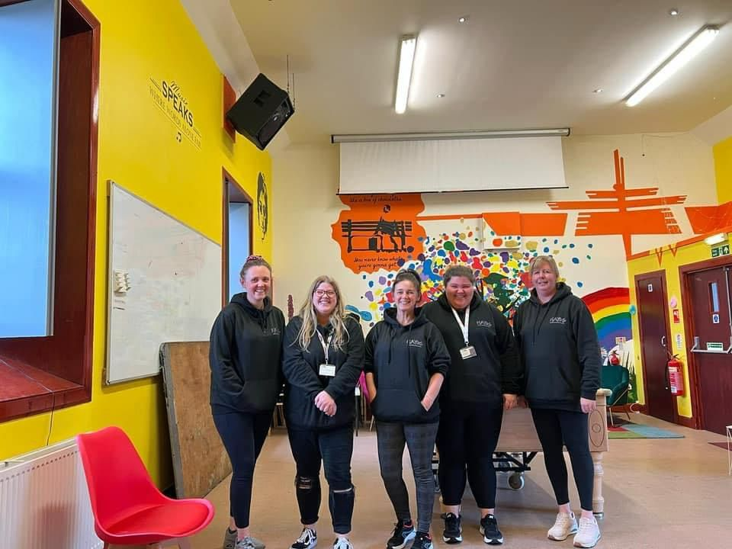they
Some of MAYDS staff.

New Development
We continue to work on our new development (wheel park and community garden) when funding permits. We are now working on phase 4 and this has seen us erect security and soundproof fencing around the site and more recently beginning the construction of the community garden. Once this stage is finished, we will move to the final phase of erecting the Wheel Park, we do not yet have a timeframe for this as it will be subject to accessing the required funding, architects, builders, etc. This development has been a long process, held up further by Covid but it is great for the organisation and the community to see it finally taking shape.
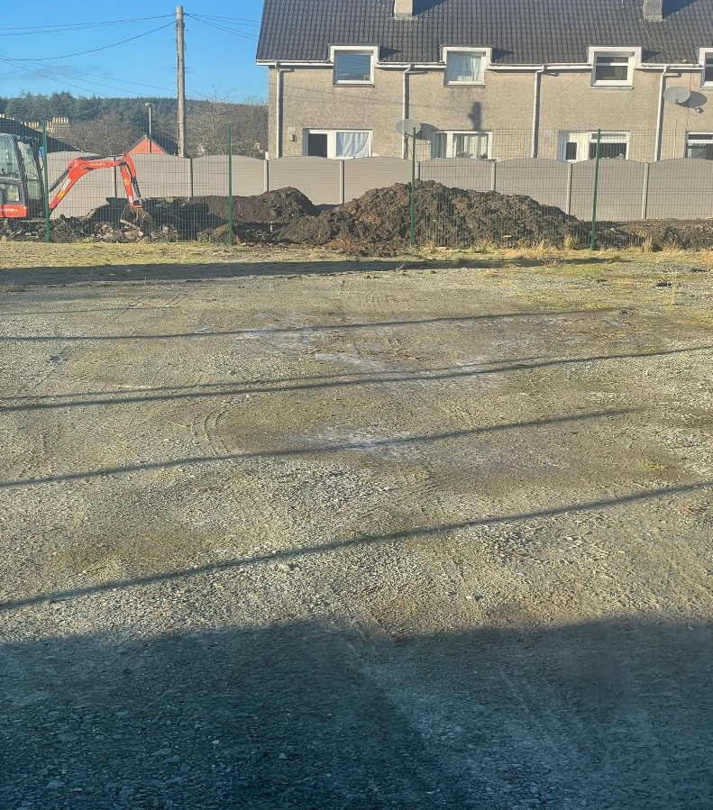
Work continuing the new development.

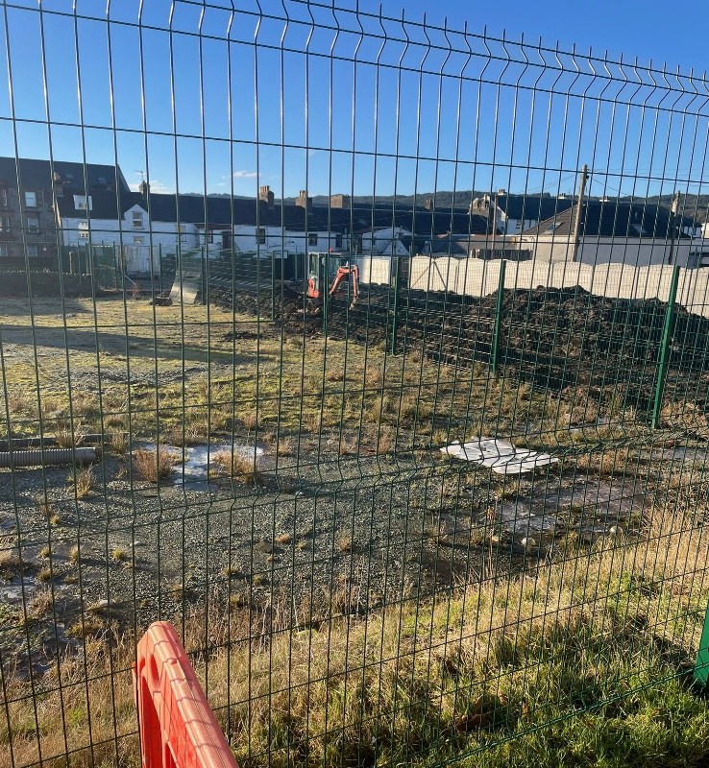
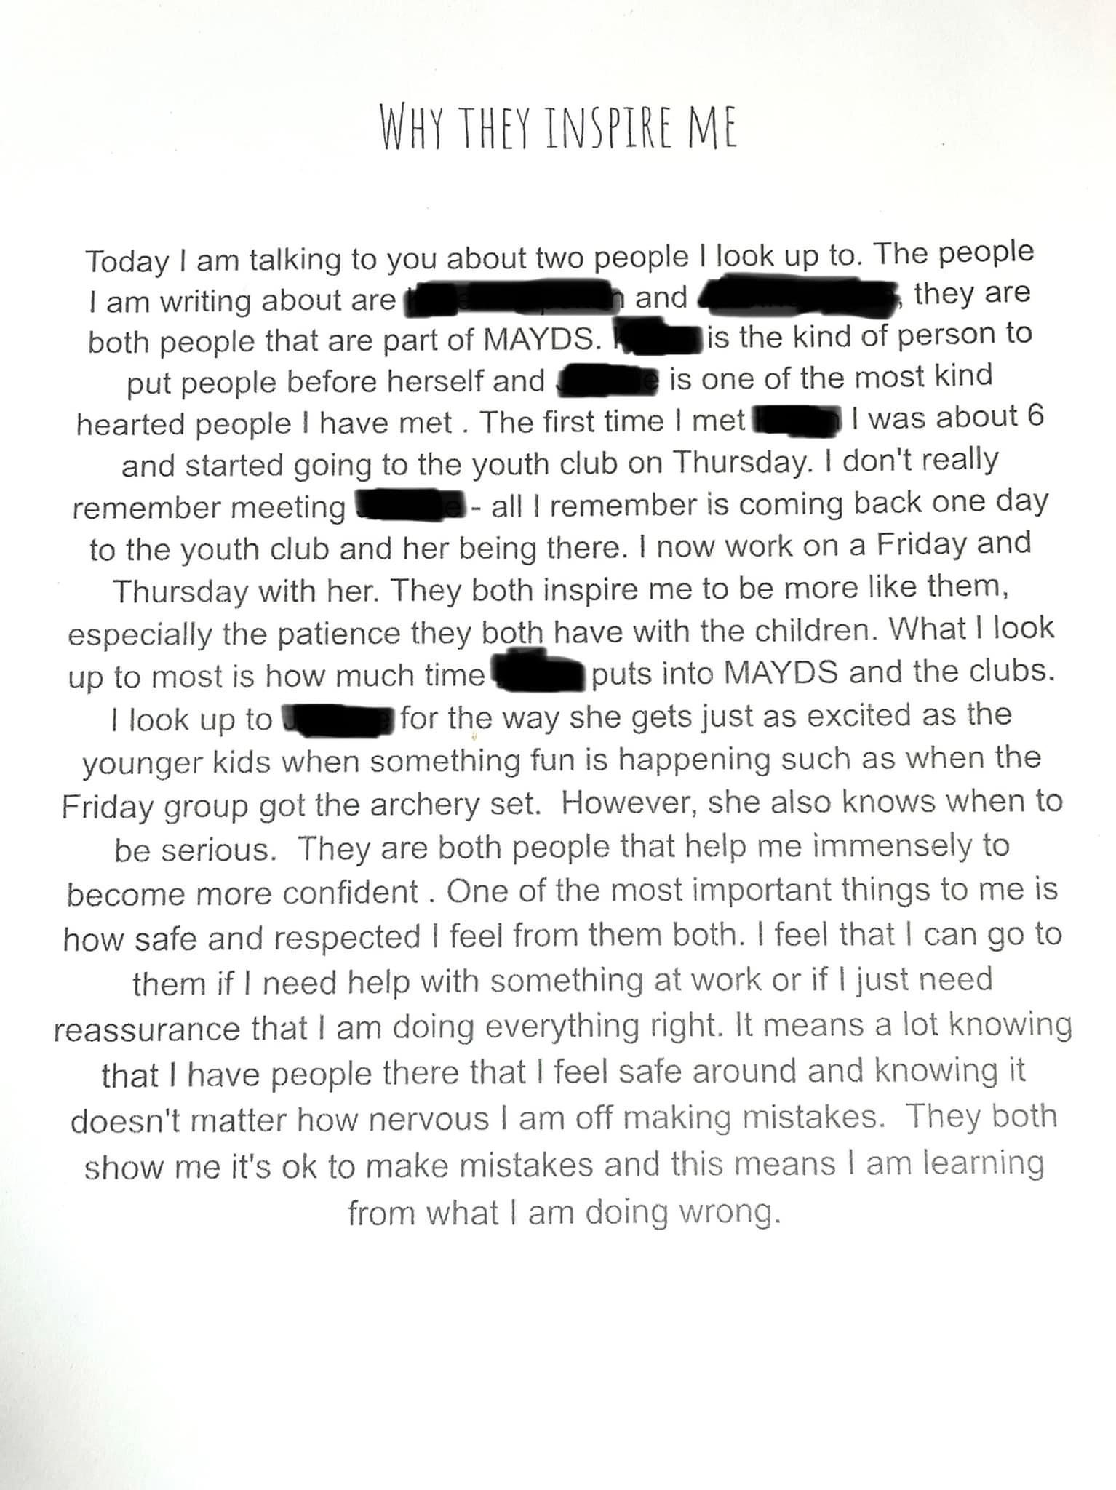
Written by one of our youth volunteers about MAYDS youth staff.

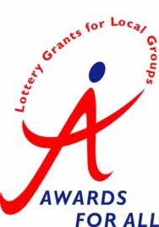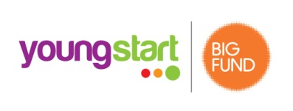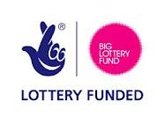
THE KILFINAN TRUST 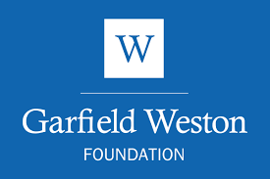
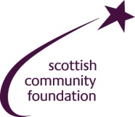
MAYDS Ltd Company number: 396832

