
Mid Argyll Youth Development Services
Registered Charity: SC022931
MAYDS Ltd Company number: 396832
50a Union Street
Lochgilphead
Argyll
PA31 8JS

ANNUAL REPORT 2024

2024 continued to be a busy year for the staff and young people at MAYDS. Clubs and diversionary activities continued to be busy and tailor support services saw an increase in referrals. In addition, we implemented some new programs including our drama club and Additional Support Needs pre-employability program. We thank the Robertson Trust for their continued support in allowing us to help provide much needed services for children and young people in the local area.

Diversionary Services
2024 saw the continuation of our robust program of diversionary clubs and activities for children and young people, these included our boys and girls free swimming sessions, junior and senior youth drop in’s, J.A.M music group etc. Youth clubs were run in Ardrishaig and Kilmartin, along with serveral sessions per week at our MAYDS base. This year, partcualrly in the Winter months we saw an increase in numbers attending our senior drop in clubs on a Friday and Saturday night, with anywhere beteween 20 to 30 attending. Theses sessions allowed a safe space for young people to meet and gather, that was off the streets and away from drinking and anti social behaviour culture. We introduced our new Drama Group on a Monday, this proved very popular with 16 members signing up. We also had two of our Youth Volunteers working at this and supporting staff at the sessions. This year the group worked on a production of the Wizard of Oz which was showcased at 3 screenings just prior to christmas. Each screening was sold out and the young people done an amazing job. Our Youth volunteers also organized a quiz night to raise funds for costumes etc., for the show, they raised nearly £500. Young people also done some fundraising for Children In Need this year via a bake sale and face painting where they raised £213. We also helod some awareness raising sessions with the groups including Young Carers Day and Children’s Rights Day.

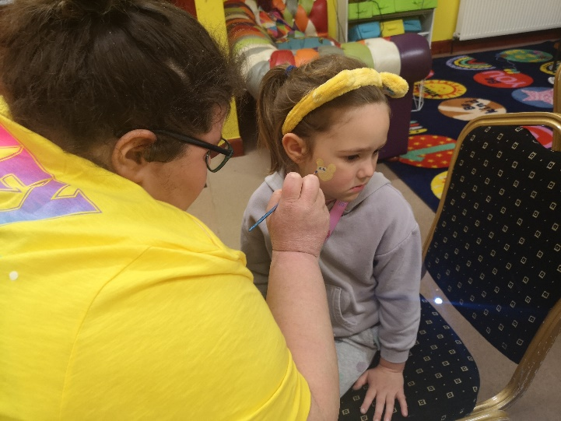
CIN Fundraising

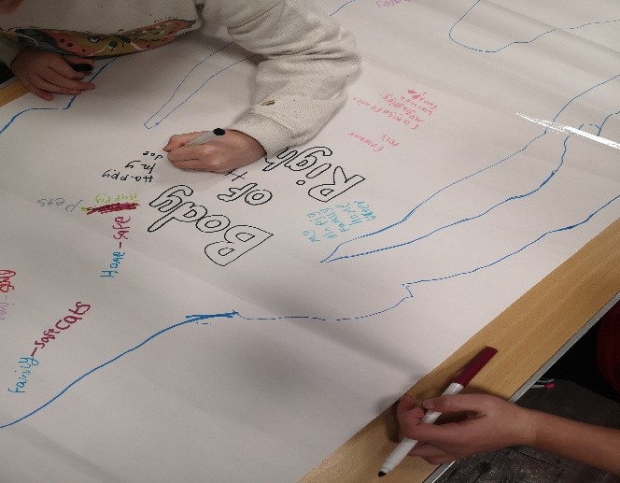
Children’s Rights Day Activities
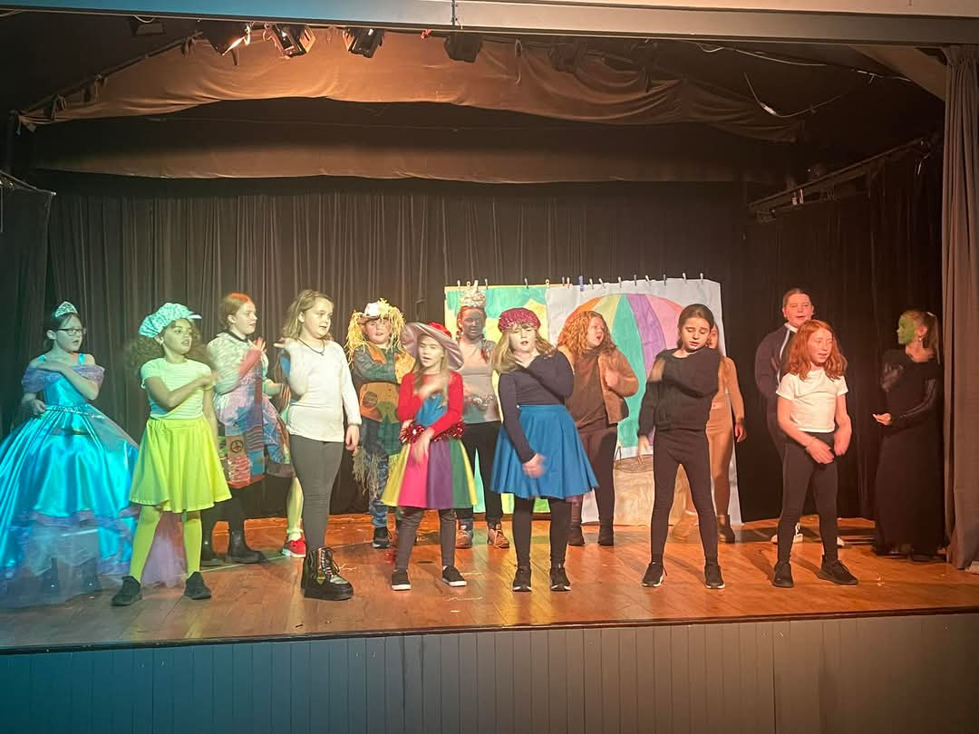

Wizard of Oz Production
Tailor Support Services
Counselling-:
January 2024 saw the introduction of our new Long Term Therapy Program on Islay. Funded by the Mactaggart Family the focus of this program was to offer residents on Islay in need of on-going support the opportunity to access therapy, not just for the standard five or six sessions but across a longer period to meet their specific needs. The counsellor worked with six individuals during the year and via weekly support managed to support significant changes in some of their lives. For example, one 15-year-old who was a non-school engager and had not left the home since Covid can now leave the home with support for short periods of time. For him and his family this is a huge step, and with the program being funded for another year he will continue to get the support he needs to continue to work on his progress.
This year the counsellor saw an increase in the number of parents she was supporting. Often, they would come for advice around issues with their children such as self-harm, non-school attenders, ASD and realise they themselves needed to talk and get support and tools to help manage different situations. On the back of this there were several family therapy sessions delivered and family therapy is an area we believe will increase in 2025. There were 12 parents and families supported over this period
MAYDS counsellor continued to work with young people across Mid Argyll, Kintyre and Islay (MAKI) on a weekly basis delivering counselling and support. There was an increase in referrals this year, particularly among the P6 and P7 age group. A lot of the issues presenting were peer and or family relationships. The counsellor used several techniques to work with and support these young people including self-management such as meditation.
Over the last year we have also continued to run the Cool2talk online support service. This is a safe confidential space where young people across Argyll and Bute can access support, advice and information. They can post questions and our counsellors will answer with advice and signposting within 24 hours. This online facility also gives young people access to counselling. This year we had 49 questions posted around a multitude of issues including relationships, friendships and mental health.

Outreach and Drug and Alcohol Education-:
Our STREET MAYDS outreach program continued to run in 2024, and we were delighted when the local Argyll and Bute Drugs Partnership (ADP) funded it for 2025. This year our staff worked in different areas and villages across Mid Argyll at high-risk times such as Friday and Saturday evenings. They would engage with young people hanging about the streets to make sure they were safe and give them advice and support and signposting if needed. This year our STREET MAYDS staff also attended community events includi8ng Bonfire Night and Ardrishaig Gala Day, these events are well kin ow for young people drinking etc., so our staff were on hand to make sure young people were safe and supported where needed.
August 2024 saw the reintroduction of the Drug and Alcohol Education Program in the schools. This program will run for the next 2 years, and during this time MAYDS staff will work with the school staff to deliver education and support service for young people around drugs, alcohol etc. In addition, we will contribute to newsletters and give advice at parents evenings. This year we have already attended parents evenings in Islay and Lochgilphead.

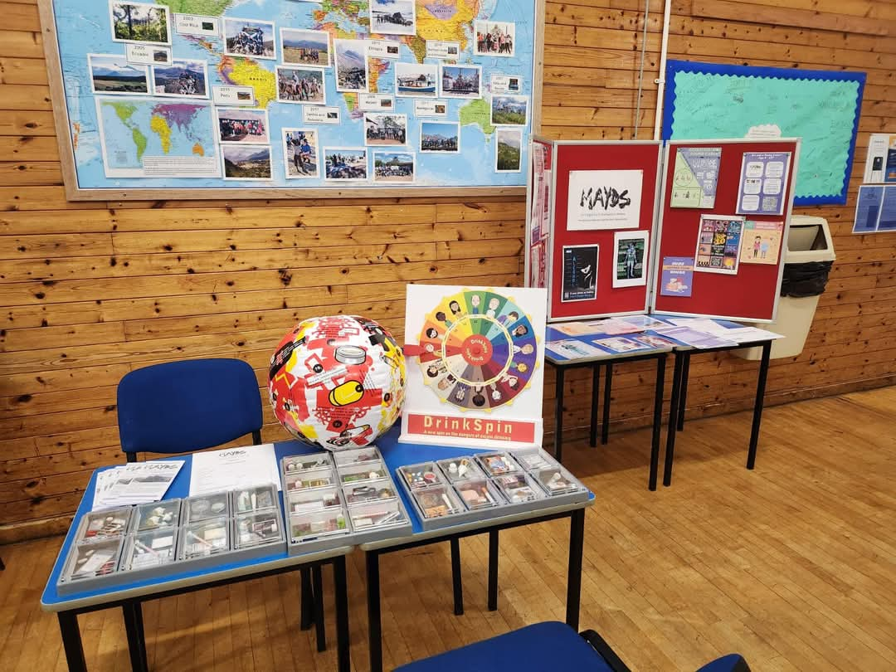
Parents Evening at Islay High School

Young Carers-:
In 2024 we had 133 young carers registered across MAKI between the ages of six and eighteen years old. Support was provided in a variety of ways including access to respite via young carers youth clubs and trips, funding, applying for Young Carres Grant, Christmas hampers and vouchers, counselling etc. All 133 have Young Carers statements are regularly meet up with our Young Carers support workers for reviews and check in’s.
For the second year we attended the Scottish Young Carers Festival in fife. This year 11 Young Carers attended the two-day, two-night event. There was a huge range of activities for everyone including cake decorating, silent disco, talent competitions, live music, inflatables etc. The young people had a ball and with over 500 young people attending from across Scotland had the opportunity to meet new people in similar situations, along with get some much-needed time away and time for themselves.

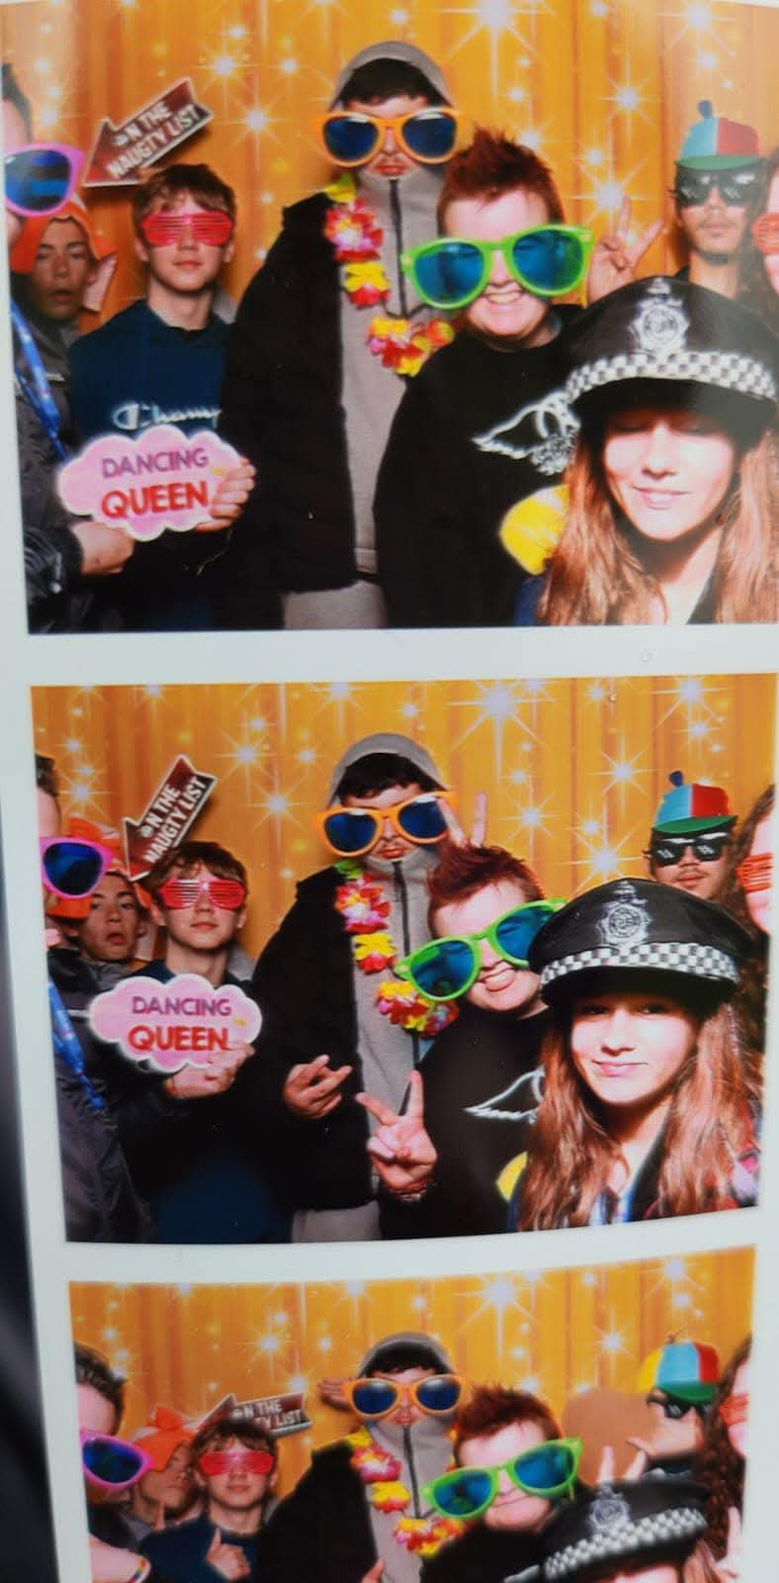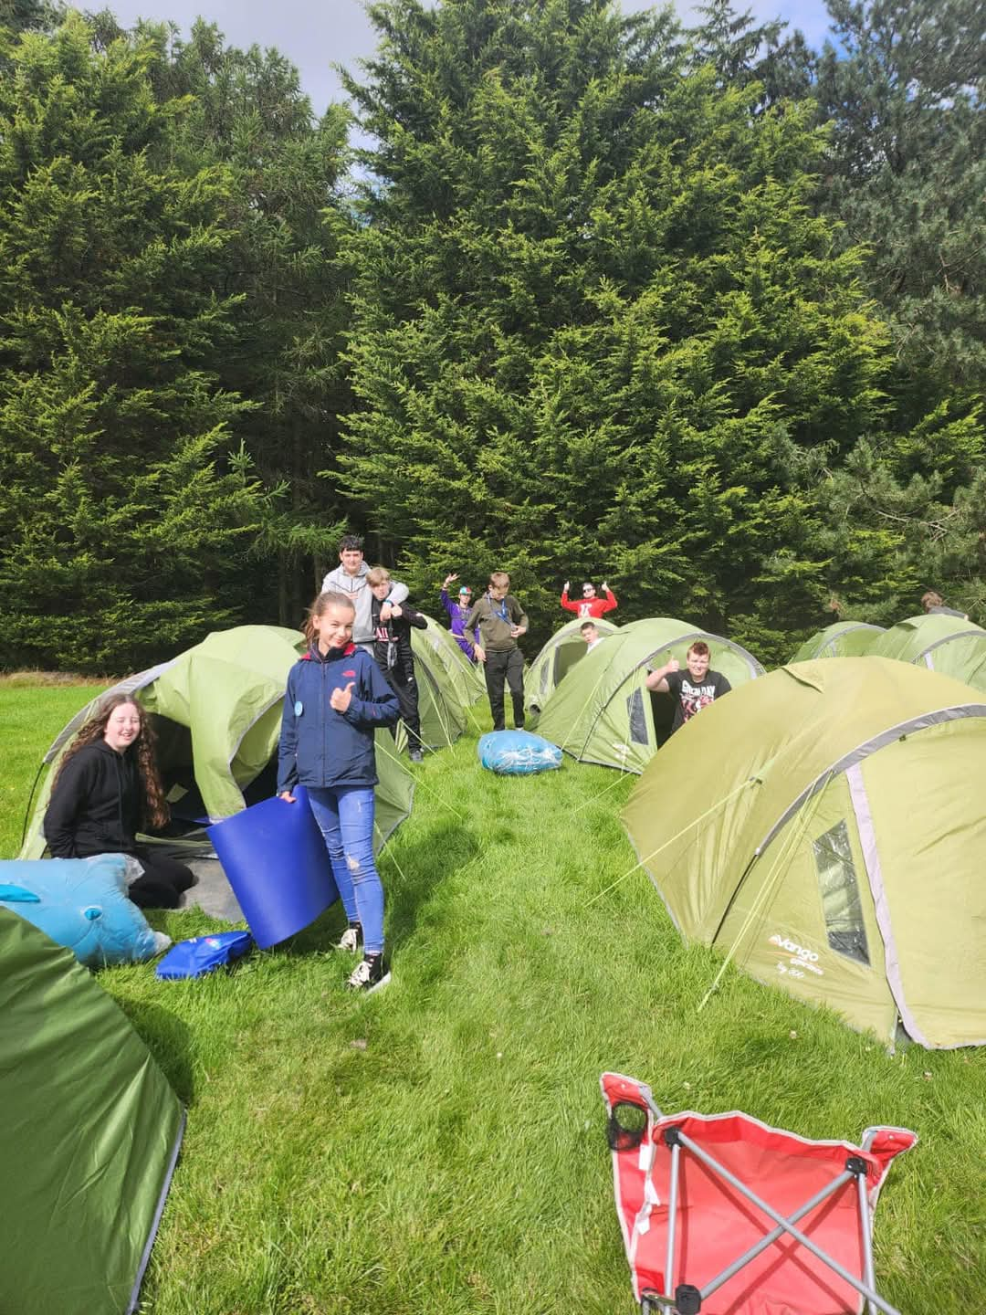

Young Carers Festival 2024

Also, this year MAYDS Manager done some awareness workshops with 15 head teachers from across MAKI at the Argyll and Bute Head Teachers Conference. These workshops highlighted issues such as signs to look for when identifying young carers, the referral process and the support our service can offer the young people.

Employability-:
Through our Employability Program (WorkingRite) we have supported 11 young people 16-19 years old to access apprenticeships, employment and or work experience opportunities. Leaving school without a positive destination these young people are referred to us to access a 17-week supported employment program. Once matched with a local employer it is hoped after this time they will be offered a job, apprenticeship or at the minimum have experience and a reference for their CV. This year we had young people placed within construction, beauty, administration, forestry, mechanics and renewables. To date two of the young people have entered employment into the forestry, one has an administration apprenticeship at a construction firm, another an apprenticeship in mechanics, one has been offered a job at a beauty salon, four are still on the program, and two were unable to sustain the full program due to mental health issues. One of the young people accessing an apprenticeship is a young carer, he struggled greatly with attendance at school and
because of is home circumstances, however with the support of the employer and the WorkingRite Program he completed his 17-week placement and was offered an apprenticeship in mechanics, which was his career goal.
We have continued our Pre-Employment support via Spark Your Purpose and the Parental support Fund. Both these initiatives have so us support around 40 young people and parents in a variety of ways to increase their employment opportunities. This has included things like driving lessons, training courses, self-employment support, equipment to start-up businesses, interview clothing etc.
For the second year we ran our Rite to Work Program. This is a partnership program with WorkingRite and Education to deliver an earlier intervention approach to young people who were disengaging in school but could not leave yet. Through the Rite to Work Program in the new academic year beginning August 2024 7 Young People began attend MAYDS for a full school day on a Monday, here they cover the certificate of work readiness course which includes working on CV’s, Interview skills, Responsibilities of Employment, setting career goals etc. In addition, they work on completing certified modules on Health and Safety, First Aid, Young People in the Workplace and Food Hygiene. This course will run till June 2025. Those on the course not entering positive destinations will progress to the WorkingRite Program.
In 2024 we also trialed a Rite to Work Program for those with Complex and Additional Support Needs. This takes the format of above but is tailored to meet the learning needs of each individual on the Program. Four students started on this program in August which is run in the schoool over two periods every Friday.
Our volunteer program continued to grow in 202, and we now have 10 regular volunteers supporting staff across the clubs and activities. Several of our Young People are now volunteers at Drama Club, ASN groups and the Dementia Choir. All our volunteers have gained training across a range of areas this year including Child Protection, Dynamic Youth and Saltire Awards etc.

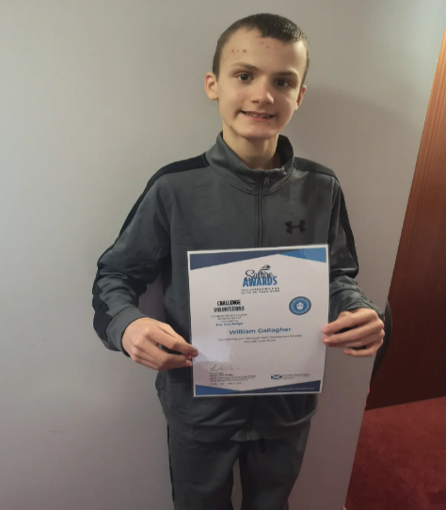 Our ASN Volunteer with his Saltire Award
ASN Support-:
In 2024 our Additional Support Needs Youth Clubs continued to run and be busier than ever. These groups are lifeline for many families and young people as they offer those with additional needs, who cannot attend any other social outlets some time with peers participating in fun activities, however it also offers the families some much needed respite time. During the year young people used the sensory room for chill time, enjoyed outdoor play in the new gardens and done baking and arts and crafts sessions. They also had a visit from Huggy the Thera pony which went down a storm. There are limited numbers that can attend these sessions as staffing is so9 high, either a one on one or one on two ratio. Therefore, we have found ourselves having a waiting list and having to implement a weekly booking system to be fair to all. To help cater for more young people we are in the process of increasing sessions from 2 to 3 per week. We hope this will start in February. We currently have 18 young people and their families benefiting from our ASN program.

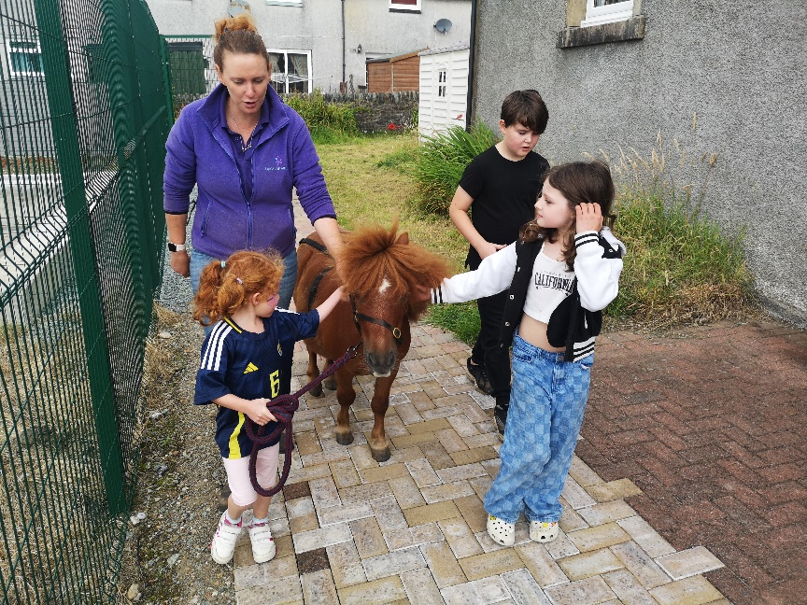
Huggy the Thera pony
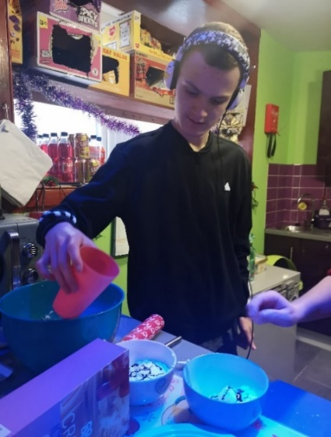
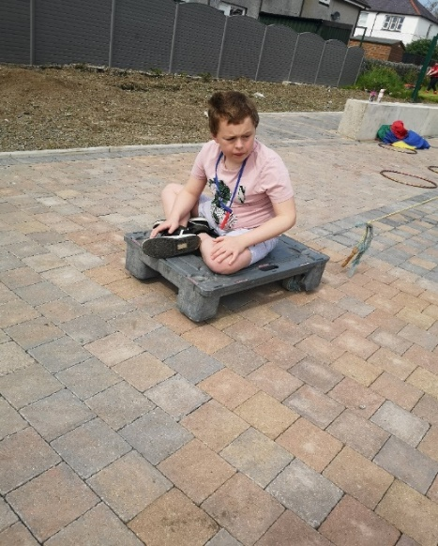
Community Links-:
This year we continued to host several community groups and partners in our premises on a weekly basis, these included the Dementia Choir, Heads Up Mental Health Group, NHS for Baby Massage and Live Argyll for their Job Club.
We also worked closely with the local food bank (Moving on Mid Argyll), providing them with a premises on our property to host a local food share shop. What was once a garage has now been refurbished with the support of local organisations such as MacLeods, Nadara Windfarm, ACHA and the Coop and turned into a mini shop where people can come along select the food they need and have a chat and a coffee along with advice and signposting from the FoodShare co-ordinator. We are hoping the official opening of the shop will be in February 2025.
We supported the local Viking Festival this year by providing outdoor activities for children and young people. Those attending participated in bush craft, den building etc. We also hosted our annual Living Well event in January 2024 at Mac Pool. This was a free event for the community to attend and get taster sessions in a variety of activities, access free swim sessions, get adv ice and sign posting around health and services from local agencies and partners, meet Huggy the Thera pony and get some free lunch and refreshments and socialise with others. 87 people attended this event.

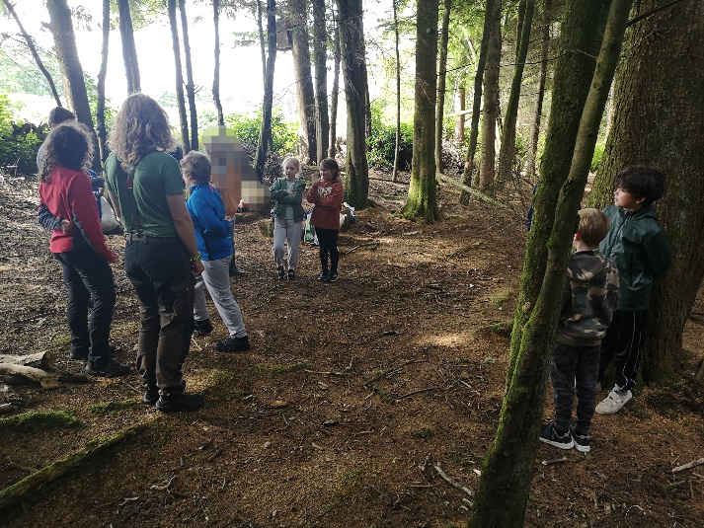
Den Building

