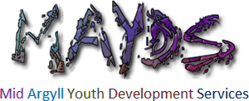

2018
A LOOK BACK

A MESSAGE FROM THE MANAGER AND CHAIR OF THE BOARD

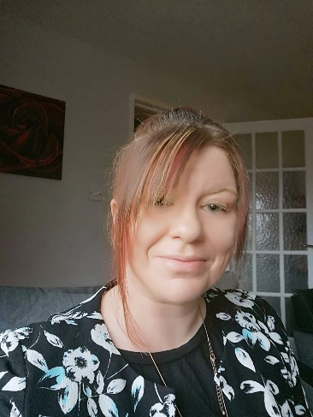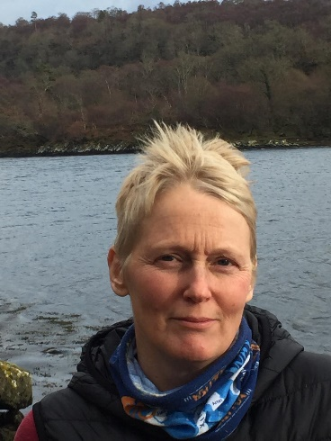
Manager Fiona Kalache Chair Jacky Preece

2018 has been a great year at MAYDS. We are now working with more children and young people than before and have continued to introduced new services and run existing programs that meet the needs and wants of the local children and young people. We continue to thank our partners and the community who support the work we do and most importantly to all our funders who make the work we do possible. Finally we would like to thank and mention all the children, young people and families who continue to participate and have input into the service and importantly make the jobs we do worthwhile.

OUR TEAM

Operational Team Volunteers
Manager -: Fiona Kalache Chair-: Jacky Preece
Exec Assistant and Trainee Counsellor-: Lynn Johnstone Treasurer-: Pasqua Facchenda
Senior Youth Worker-: Karen Murdoch Trustee-: Raymond Flanagan
Youth Worker/Music Coach -: Neil Parkinson Trustee-: Peter Hogbin
Youth Worker-: Andrea Fisher Trustee-: Mark Middleton
Youth Worker-: Caroline Smith Volunteer-: Kevin Poppleton
Youth Worker-: Nathan Rummney Volunteer-: Aidan Kerr
Youth Worker-: Sarah Nicolson Volunteer-: Connor Campbell
Youth Worker/Dance Tutor-: Eve Maxwell Volunteer-: Christina Simpson
Drama Coach-: James Quorton Volunteer-: Hannah Nicolson
Cleaner-: Katie Sinclair Volunteer-: Rachel Murdoch
Volunteer (Dance)-: Leah Mackenzie
Volunteer-: Delores Firth
Volunteer-: Mark Johnston

For full team profiles and pictures visit our website at www.mayds.org.uk
NEW PROGRAMS AND SERVICES FOR 2018

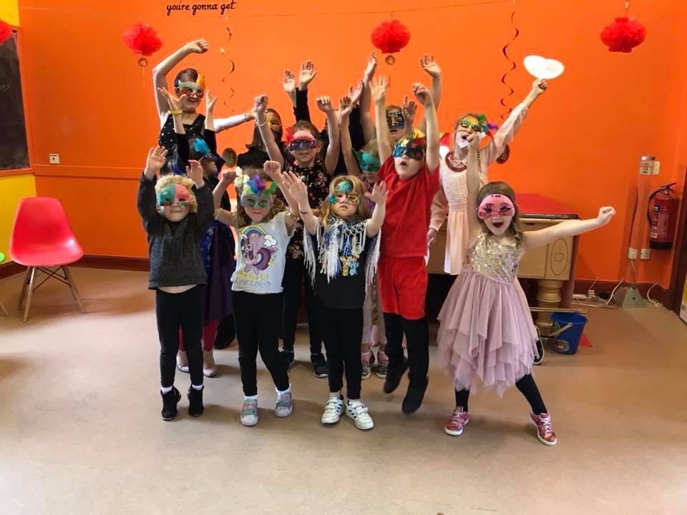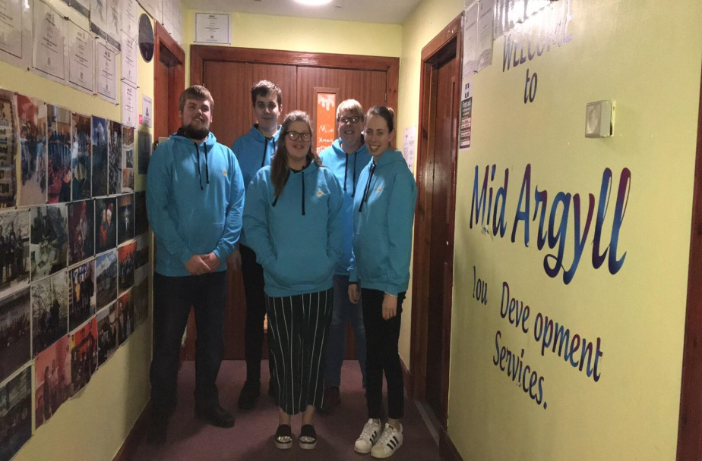
Creating a Drama Group Banking Buddies

2018 saw some new and exciting projects and services being introduced to Mid Argyll Youth Development Services. Our ‘CREATING A DRAMA’ program (funded by Awards for All) started at Easter and is the first and only drama group in the area for primary school children. It was developed by demand from young people and their parents and has been a huge success to date having had over 20 members. In the summer they had a week’s Drama Camp ending in a public performance of a folk Tale. The program will continue in 2019, hopefully attracting more members and developing new plays etc.

BANKING BUDDIES was an initiative developed by 5 of our young people and funded by Youth Scotland Money Matters Program. The aim of the program was to make banking more accessible and understanding for young people locally through peer to peer engagement. Working closely with the Clydesdale Bank the group developed a series of workshops that can be delivered to young people all around setting up bank accounts etc., as part of this a leaflet and quiz were also made.

Due to popular demand MAYDS redeveloped its dance group in 2018 after a couple of years break. MAYDS DANCE COMPANY began in September with two new Dance Tutors and now opened to a wider age range of children and young people. There are 3 sessions running a week, Wednesday P1 to P4 from 4 -4.45pm, Wednesday P4 to P7 from 5 – 6pm and Friday S1 up from 5 – 6pm. This program continues to be hugely popular with over 45 members between the 3 sessions. All dancers performed routines at the year’s Christmas Light’s Switch on celebrations.

2018 saw MAYDS take its MOBILE SKATEPARK on tour. As well as locations around Mid Argyll such as Furnace and Kilmartin gala days we also went to Islay. Young people of all ages thoroughly enjoyed using the half-pipe and mini ramps. We hope to get out and about to more areas in 2019.

Thanks to funding from Creative Breaks our Surf’s up and Away program began. This was a twofold project that consisted of FREE SURFING SESSIONS and a 2 day residential to LOCHGOILHEAD ACTIVITY CENTRE, both programs to offer respite for young carers. The free surfing saw our staff take young carers Pete’s Surf School every second Saturday. For many this was a new and exciting activity and over the weeks the young people grew more confident and improved greatly on the boards. The 2 day trip to Lochgoilhead took place in April and allowed us to take 45 young carers from across MAKI away for respite and fun. There was lots of laughter and fun activities including bell boating, power boating, mountain biking, orienteering, bush craft and lots more. This was an amazing experience for the young people allowing them to create memories and new friendships.

Mobile skatepark on Islay Surfing Fun
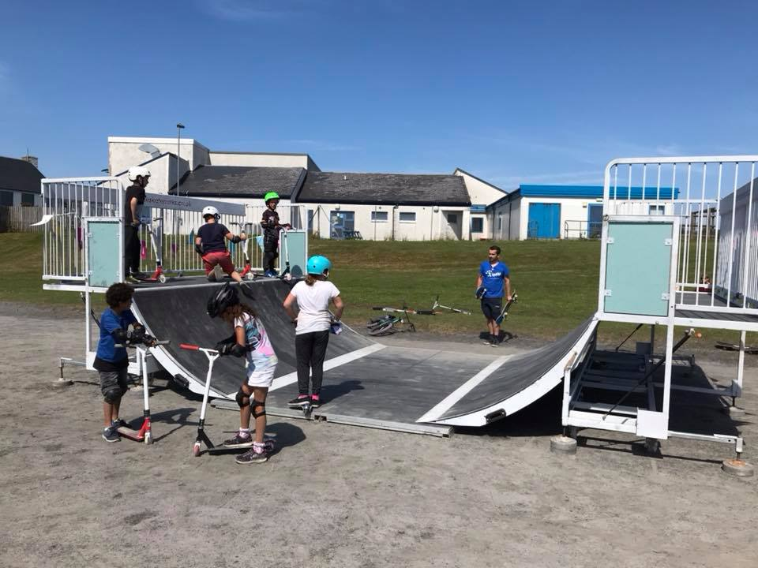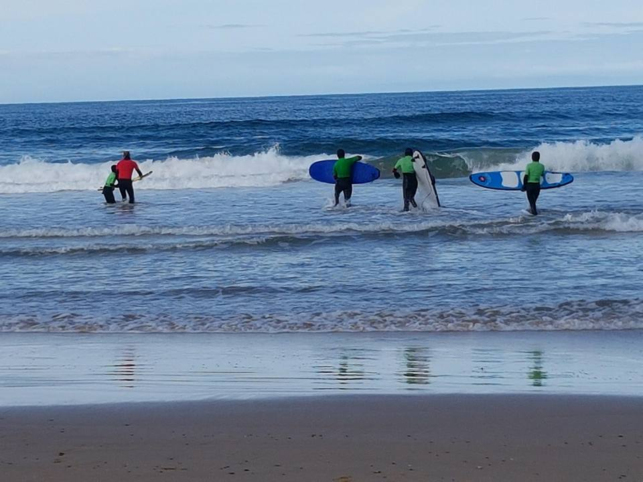

MAYDS Dance Company
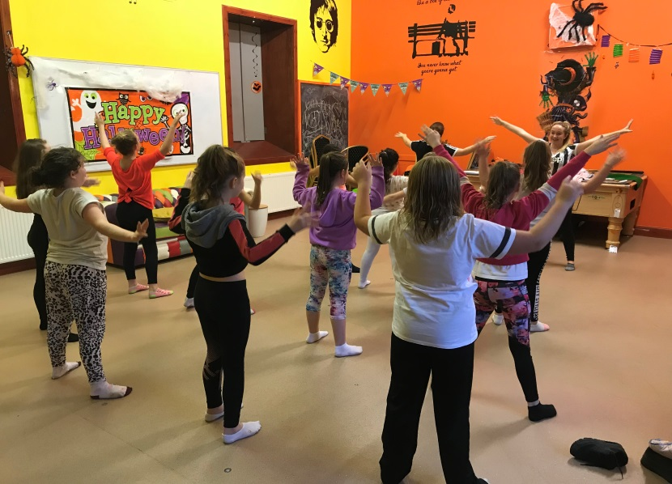

Thanks to 3 year funding from BBC Children In Need and The Robertson Trust in 2018 MAYDS was able to introduce its professional CHILD AND ADOLESENCE COUNSELLING SERVICES. Over the years it had been identified that there were no professional counselling services for children and young people in the area meaning many young people were unable to access support they needed. The funding we have received has allowed us to bring a professional counsellor, for the next 3 years, from Glasgow once per month to undertake sessions with young people who need help and support. It has also enabled one of our own staff members to undertake the Counselling Diploma over the next 3 years so at the end of the counsellors funded period MAYDS will have its own fully qualified Child and Adolescent Counsellor giving capacity to see more young people on a more regular basis.

In October 2018 MAYDS secured the contract from Argyll and Bute Council to deliver the statutory obligations for YOUNG CARERS SUPPORT SERVICES across Mid Argyll Kintyre and Islay (MAKI). As part of this work MAYDS will be delivering workshops in every primary and secondary school across MAKI, to both students and teaching staff, to raise awareness of young carers, how they can be identified, what is available to them and how they can be supported. In addition MAYDS will be responsible for making sure that every young carer identified or referred within these areas has their own individual Young Carers Statement and Support plan.

Our new STREET MAYDS INITATIVE began this year thanks to funding from the Scotch Whisky Action Fund. This initiate saw our qualified staff carryout outreach work on the Streets at weekends and holidays (high risk times for underage drinking etc.). The aim of this program was to make sure young people were safe, offer advice and support if need be and offer them alternatives etc. to hanging around the streets. Thanks to this initiative numbers at our Friday clubs doubled and we began opening on Saturday’s due to demand from young people.

MAYDS ON TOUR. This year our staffs were out and about promoting the work they do and services they provide. They went to the various community councils etc. telling them about services and the new development. We also went to Islay with 2 young people and attended the Community Planning Partnership where we showed members the new plans for the MAYDS recreational centre. In addition to being out and about we hosted some visitors to our centre. The staff and board members from Islay Cyber Café visited in September to see what we do and how we run then in November 2 of our young volunteers hosted a Scottish themed event from social enterprise visitors from around the world. The young people made them a haggis lunch, gave them a tour of the centre and talked about the activities they were involved in.

UPDATE ON EXISTING PROGRAMS AND SERVICES

Boys in Action 2018
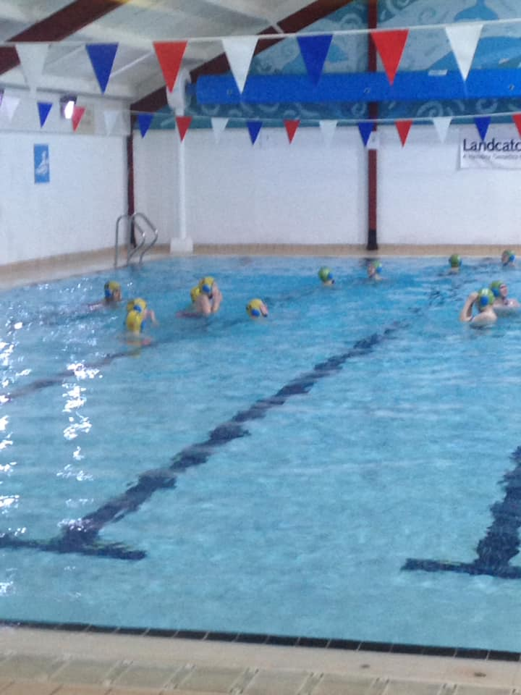

This year our diversionary program of activities has gone from strength to strength and we are now delivering more projects and programs than before. BOYS IN ACTION and GIRLS ON THE MOVE, free swimming sessions for boys on a Monday and girls on a Tuesday, have continued to prove popular. With up to 25 boys attending their session they have had fun with activities such as water polo (photo above), relay races, volleyball etc. The girl’s sessions have been overwhelming with up to 55 attending any given session meaning we have now had to split the group and run 2 sessions on Tuesday to allow the pool to safely cater for the numbers. This year the girls have had the aqua run, fun with the floats etc. We are delighted this initiative proves so popular and has being a positive outlet for so many young people.

Our J.A.M (JUST ABOUT MUSIC) GROUP has had positive changes and good success this year. In January they had workshops and developed a single with professional band James Edwyn and the Borrowed Band. The new music Youth Work lead, Neil Parkinson, also started this year and he has been doing great work with the young people who come along to J.A.M. They have done a fundraising concert at Ardfern which they ran and organised and great performances at the Christmas lights switch on. To celebrate their success and commitment the young people were given gold disc awards.

Workshops with James Edwyn
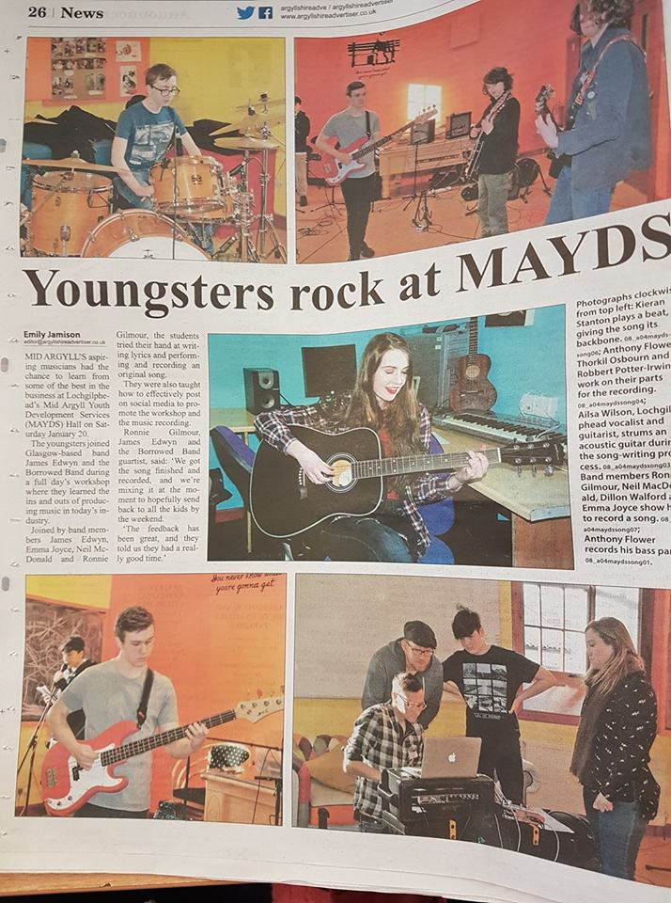

Paintball 2018
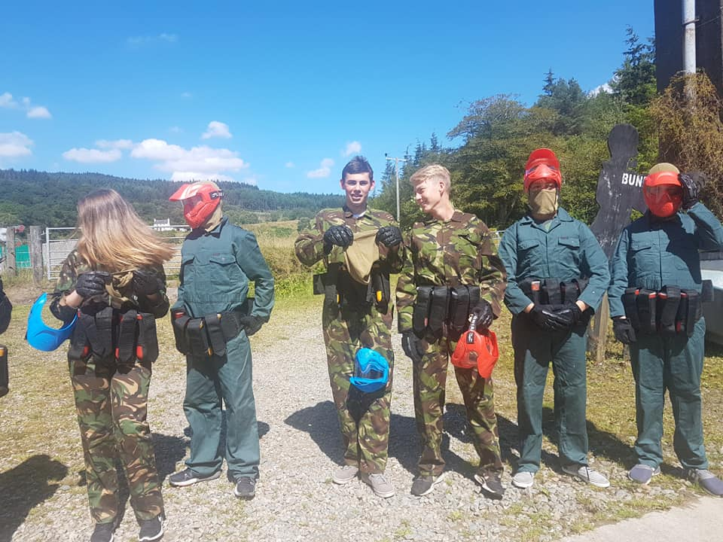

This year our YOUTH DROP IN’S continued to be busy. On Thursday evening our two sessions (Five Alive Club and 6 to 8’s In Action) see around 45 young people attending. At these sessions there are lots of fun activities such as games, baking, art’s n crafts, outdoor play, Halloween discos etc. In addition these groups decorated a Christmas tree for the local church fundraiser. On Friday evenings our S1 and up Chill out night has doubled in numbers with now over 25 attending. On Friday evenings the young people like gaming, watching movies, having pizza nights etc. This year they also organised a Tea Dance for elderly community members and a Greatest Showman cinema night which also raised money for the group. Our Friday Ardrishaig Drop In continues to run, again numbers are good and young people participate in lots of fun activities and sports. This year due to demand we also opened on a Saturday evening for senior youth club, young people just come along and chill in a safe and welcoming environment.

We had lots of TRIPS AND OUTINGS in 2018. We had several trips to Argyll Adventure where the young people done activities such as paintball, laser tag and crossbow. We had horse-riding and pony club sessions. We visited the popular Unit 23 skatepark in Dumbarton where the young people had fun on their scooters, skateboards and bikes. In Oban we visited the Chocolate factory and Atlantis Leisure. To finish of the year MAYDS paid for 66 young people and their families attended the Cinderella Pantomime at the SECC. Everyone had a fantastic time.

Once again the annual CHRISTMAS LIGHTS SWITCH ON event was held at the MAYDS building. With free tea, coffee, hot chocolate, mince pies and entertainment the night was busy and a great success. It was nice to see young and old community members come together to celebrate the festive season. Santa was busy all night in his grotto with gifts for everyone, our dance troupe entertained the crowd outside with festive performances and the J.A.M music group were in the hall rocking the Christmas tunes.

Our annual SPORTS NOT ON THE GREEN 2018 took place on the 29th June. The weather was great and there was a huge turnout for a packed night of sports and fun. This year there was taster sessions in football, rugby, athletics, golf etc. We were joined again by professional stuntman Dom Kinnard, who also delivered workshops with young people in the school earlier in the day. MAC Pool came along this year with their peddalos and our own mobile skate park kept the bikers and skate boarders entertained all evening. As always there were plenty of free giveaways for everyone from footballs and rugby balls to swimming goggles, hula hoops and skipping ropes.

YOUNG PARENTS/FAMILY DROP IN continued to run on a Monday from 12-3pm. Thanks to funding we were able to invest in some mobile soft play equipment for the group which has proved extremely popular. We had a number of new members this year meaning we now see up to 18 at any given session. We were also lucky to have 7 t sessions from the Read, Talk, and Play Team in 2018. Their professional and trained staff came along to the group and carried out parent and child interactive session which included things like messy play, rhyme time etc. We also had visits form Rosie Cheeks, Book Bugs, Citizens Advice and Fyne Homes.

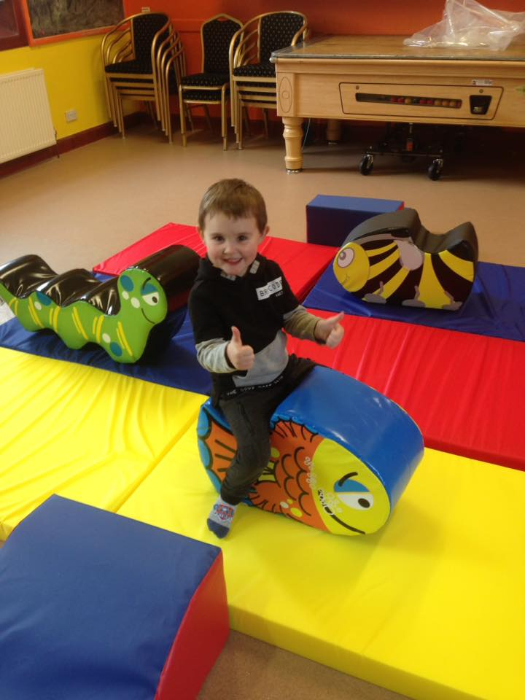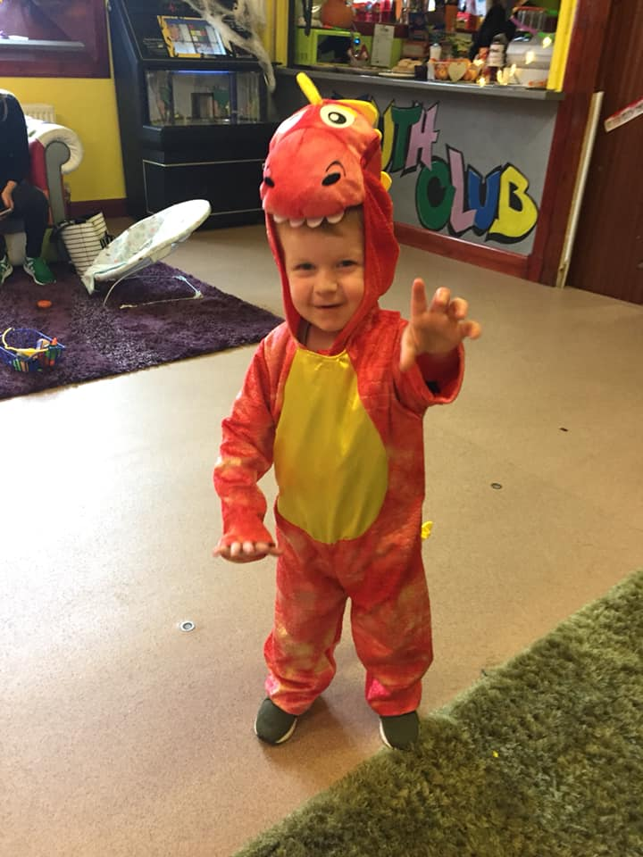
Soft play gets thumbs up. Halloween Fun at Family Drop In

This year was busy for our VOLUNTEER, TRAINING AND EMPLOYABILTY SERVICES, both in terms of supporting young people into positive destinations and staff and volunteers increasing professional and personal development. During the course of the year staff and volunteers participated in a number of different training courses ranging from COSCA Counselling Skills and Solvent Misuse to Online Safety, Alcohol and Drugs, Cannabis and Youth Achievement Awards Training. Staff and volunteers also attended the Big Skills Weekend in Stirling where they participated in a range of workshops including games, mental health, money matters, dance, team building, music production etc. This year we supported young people to complete Dynamic Youth Awards and HI 5 certificates, they also participated in courses such as Cooking on a Budget, First aid, Food Hygiene, Work ready certificates etc. We continued our partnership with workingrite which saw us support young people into work placements leading to fulltime employment and apprenticeships in places like the fish farms, Renewables and construction. Through our TENANCY SUPPORT PROGRAM we continued to assist young people with their independent living skills through sessions on budgeting, being a good neighbour, managing debt and paying bills etc. For this project we continued to work alongside partners such as Police, Citizens Advice and Fyne Homes. This year also saw us support families most in need with food parcel donations.

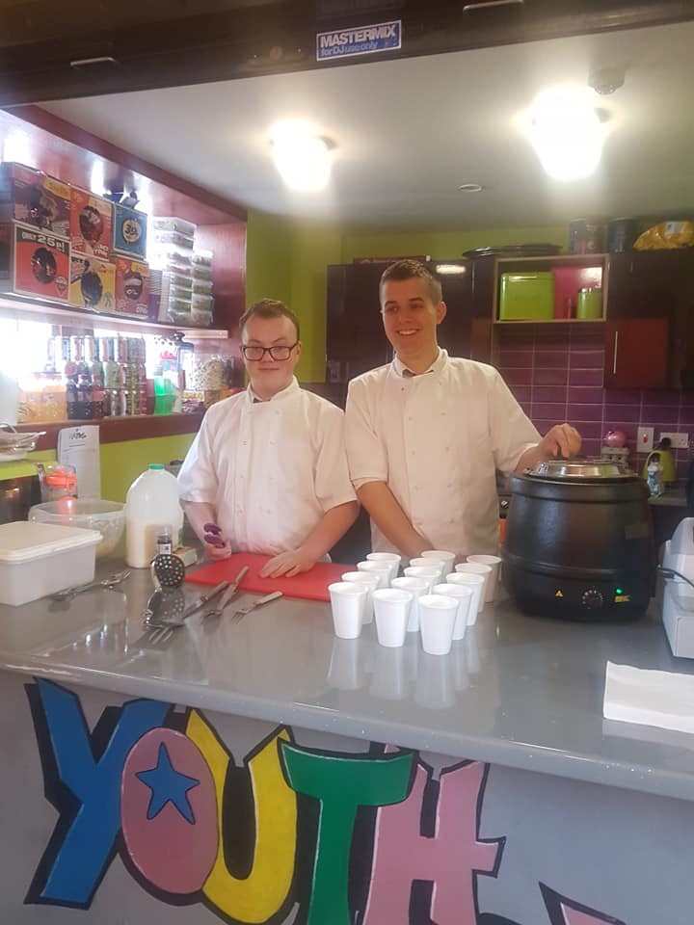
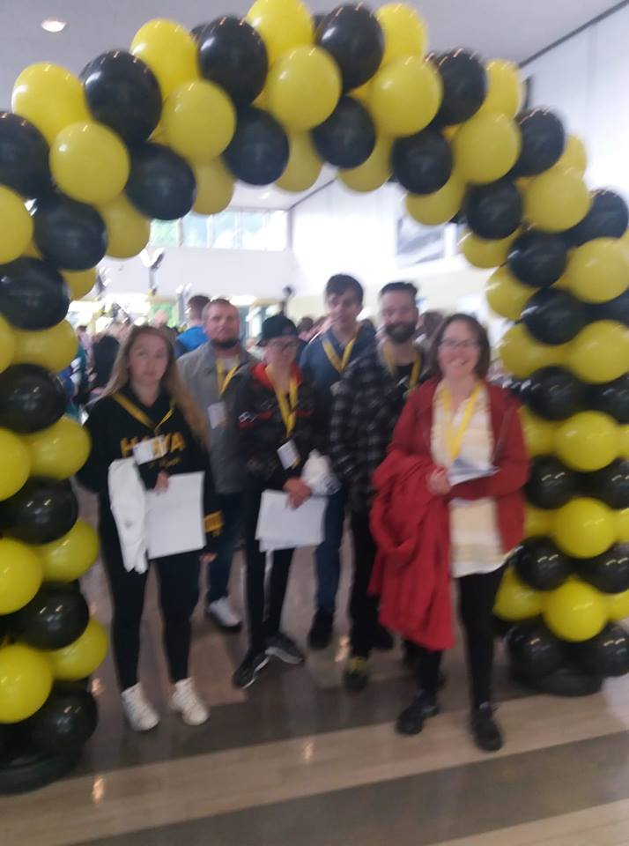
Big Skills Weekend Youth Volunteers Kevin and Aidan
Our promotion and support of the COOL2TALK online support service for young people continued this year. We carried out live demonstrations in Tarbert, Islay and Lochgilphead schools so young people could see how to access the services support and information pages. We also provided support at the S3 Health Dramas by being on a panel with other agencies to answer questions asked by the young people. The drama touched on very sensitive subjects such as self-harm, suicide, LGBTQI and for some students was quite emotional but also very powerful and well received. Our work around ALCOHOL and DRUG EDUCATION and 1 TO 1 SUPPORT within Islay High School, Tarbert Academy and Lochgilphead Joint Campus continued to run throughout the academic year. We visited the schools delivering various sessions to all year groups that included topics such as alcohol, drugs, smoking, peer pressure, consent, online safety, energy drinks etc. In addition to this we supported a number of young people on a one to one basis who were referred to us due to concerns around their substance use.

While we secured the new contract for the Statutory Young carers Services this year also kept running our YOUNG CARER ACTIVITY/RESPITE services which saw us support young people into attending activities and outings for some time away from their caring roles. One of these more popular activities among young carers was horse-riding and pony club. This saw us take young carers to Argyll Adventure on Sundays where they went for a pony ride and then done some activities around stable management etc. The young people loved this because as well as time out they were also gaining certificates and badges as the weeks went on.

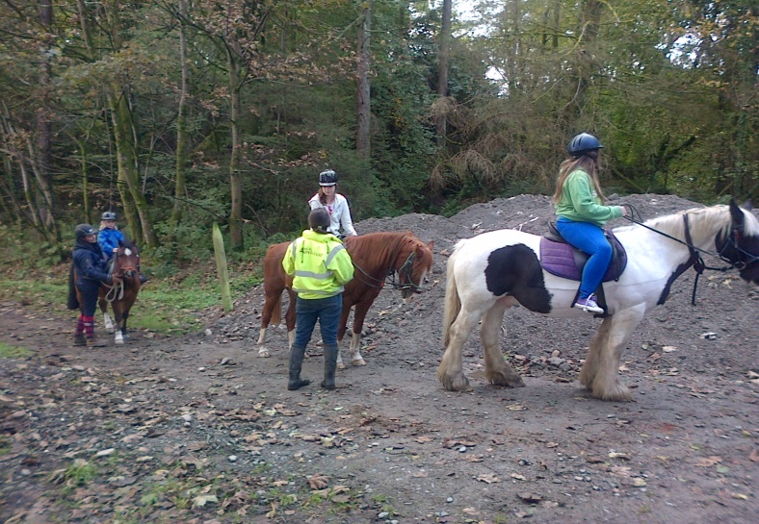
Pony Club

Finally work on our NEW DEVELOPMENT continued to progress this year. With the land sales all complete and architects drawings done we were able to complete our long term business plan, investment strategy, planning, costing and meet with funders to move forward with application processes. It is hoped next year we will apply to several funders for the capital investment to move forward.

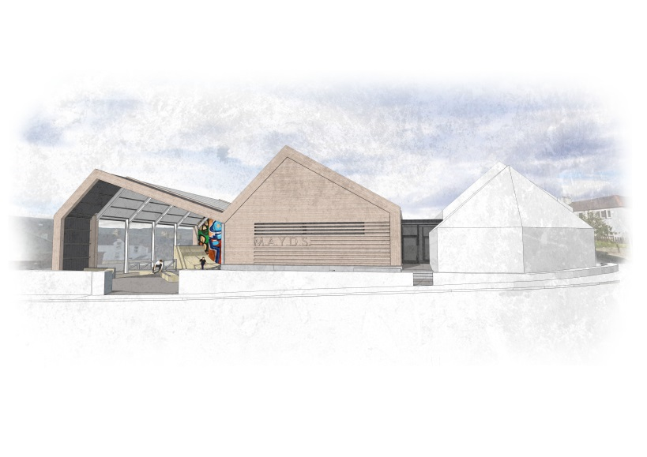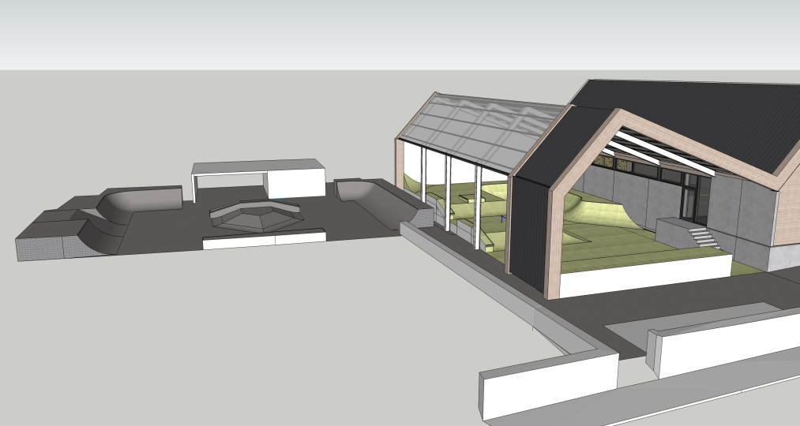
Face on image of New Development Skate Park image of New Development

OUR FUNDERS IN 2018
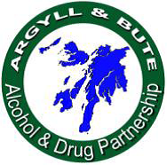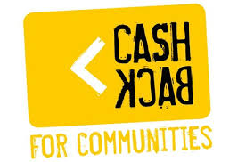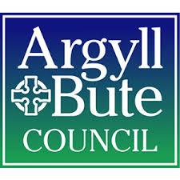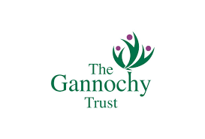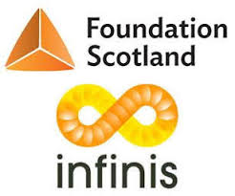

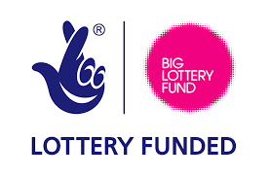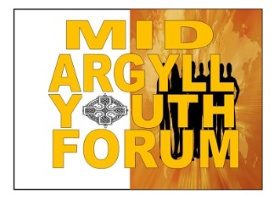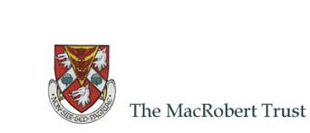
THE KILFINAN TRUST Mid Argyll Substance Misuse Forum
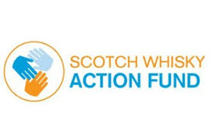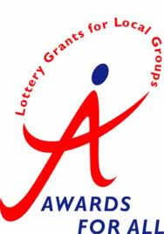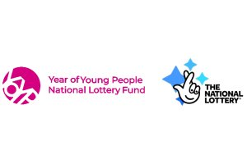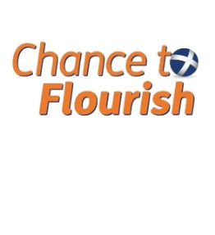
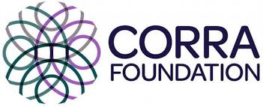
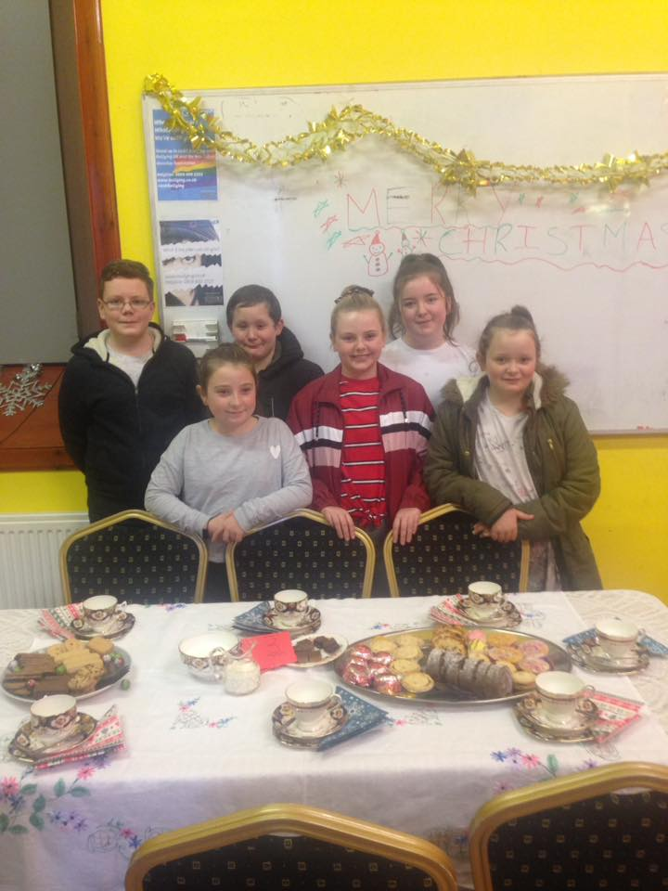 HAVE A GREAT 2019
